SVCR GOVT. DEGREE COLLEGE
Gudiyatham Road, Palamaner,
Chittoor, A.P - 517408.
(Affiliated to S.V. University, Tirupati)
(Re-accredited by NAAC with ‘B+’ Grade)
http://www.gdcplnr.edu.in
STUDENTS WIN CASH PRIZES AND CERTIFICATES AT NATIONAL CONSUMER DAY CELEBRATIONS, CHITTOOR
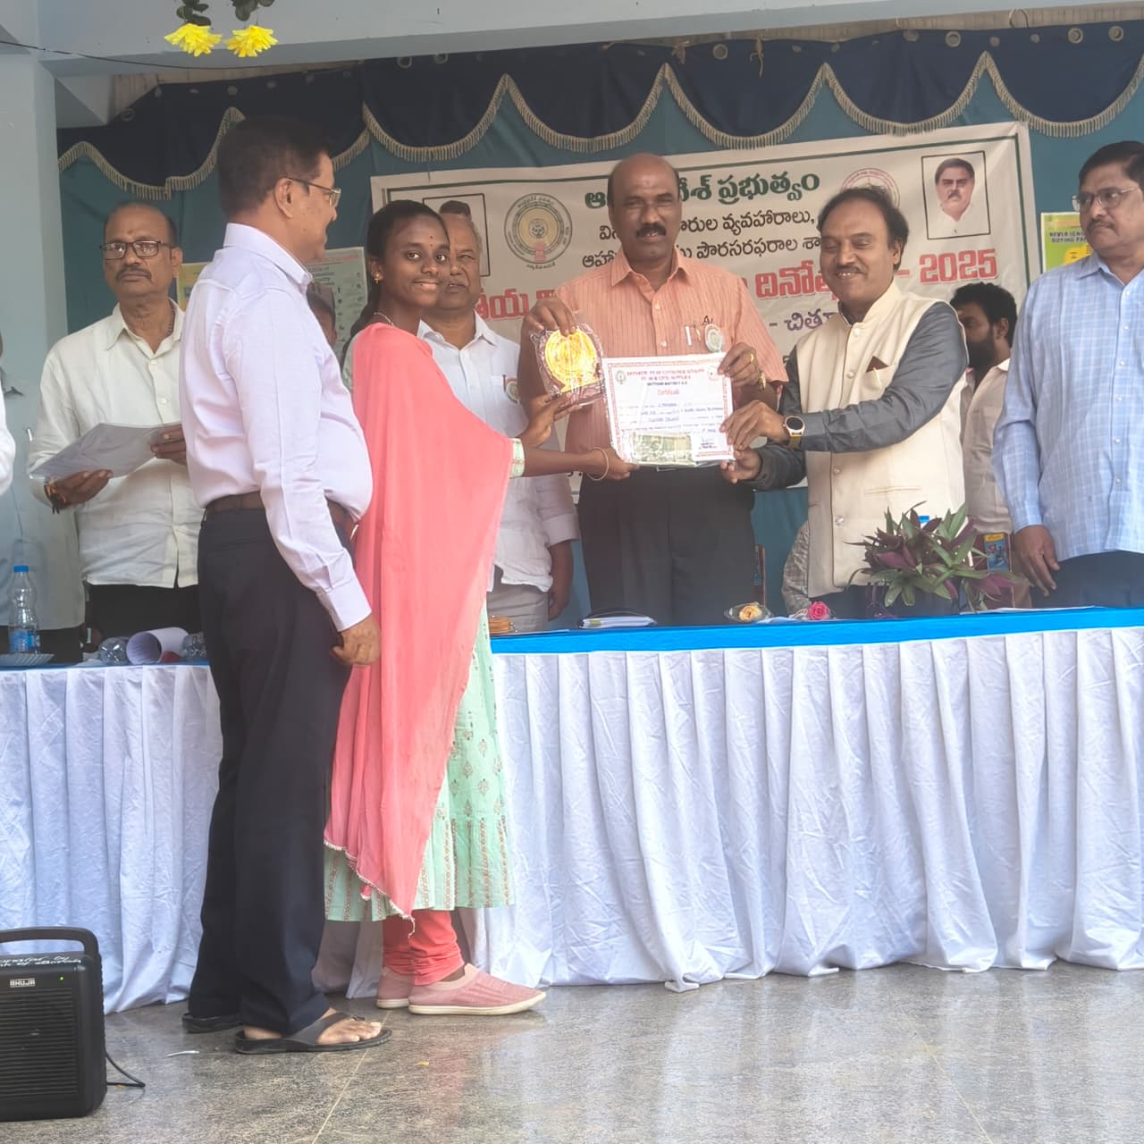

NEWS LETTER FOR THE
MONTH OF DECEMBER - 2025

Editorial Board
Editor |  | Dr. M.Venkatesulu, Principal
Editorial Board Members
1. | Dr.K Nandeswaraiah Lecturer in Commerce
2. | Sri M. Kiran Babu, Lecturer in Mathematics

Year: 2025 Month: December
Vol: I Issue: 12
Prepared and Released by Dr. M.Venkatesulu, Principal

PRINCIPAL’S DESK

To nurture the future of the student is the main objective of the chair. SVCR Govt. Degree College puts forth all the might to bring light in the lives of the marginalised section of the students. The college here represents the stake holders. The holistic progress of the individual student is much cared about.
A familiar rapport brings the students near to the hub of knowledge. To bring out the hidden talents of the student the cultural club and to ensue social responsibility RRC and to impart social discipline NSS and NCC are working. The students’ skills are sensitised through Jawahar Knowledge Centre and Andhra Pradesh State Skill Development Centre. The college offers a well-equipped gym and a sports pavilion where the students can satisfy their thrust to become fit for future. Summative and formative evaluation sharpens the wits.To nurture the future of the youth with care is the primary objective and mission. Along with to nurture greenery in the campus and to make campus a clean arena of studies is the goal through which steps are being taken.

INDEX
S.NO | NAME OF THE PROGRAM | DATE
1 | NSS SPECIAL CAMP AND AWARENESS RALLY ON THE OCCASION OF ADIS DAY AT GADDUR VILLAGE | 01.12.2025
2 | ADIS DAY | 01.12.2025
3 | HEALTH CAMP CONDUCTED AT GADDUR VILLAGE | 02.12.2025
4 | SELECTION OF STUDENT FOR SV UNIVERSITY VOLLEYBALL TEAM | 02.12.205
5 | ANIMAL SANITATION PROGRAMME AT GADDUR VILLAGE | 04.12.2025
6 | NATIONAL ENERGY CONSERVATION DAY | 15.12.2025
7 | ONLINE QUIZ OCCASION OF NATIONAL MATHEMATICS DAY | 22.12.2025
8 | NATIONAL MATHEMATICS DAY | 22.12.2025
9 | QUANTUM TALK BY HCM SRI NARA CHANDRABABU NAIDU GARU | 23.12.2025
10 | CAREER GUIDANCE PROGRAMME | 24.12.2025
11 | STUDENTS WIN CASH PRIZES AND CERTIFICATES AT NATIONAL CONSUMER DAY CELEBRATIONS, CHITTOOR | 24.12.2025
12 | VEER BAL DIWAS: VOICES HONOURING THE SAHIBZADAS’ SACRIFICE | 26.12.2025

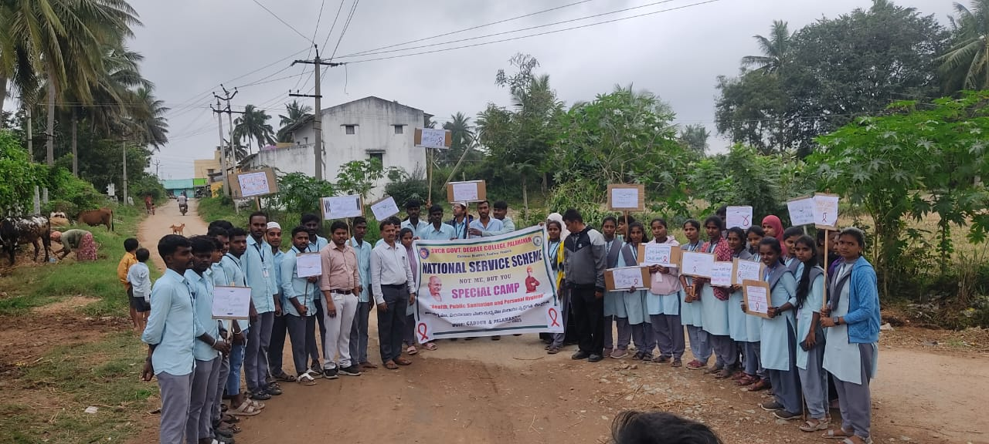
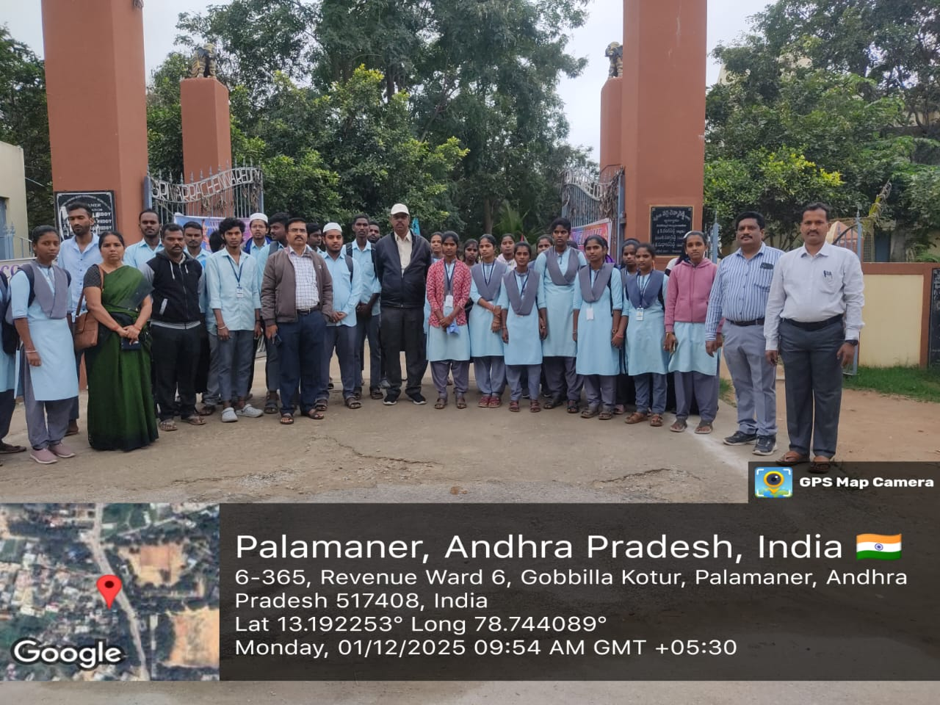

NSS SPECIAL CAMP AND AWARENESS RALLY ON THE OCCASION OF ADIS DAY AT GADDUR VILLAGE
01.12.2025
Report:
The NSS Unit organized a special camp at Gaddur Village in connection with ADIS Day to create awareness about the values and ideals of Dr. B. R. Ambedkar. The programme aimed to promote social equality, unity, and civic responsibility among the villagers.
As part of the camp activities, NSS volunteers actively participated in village cleaning, interaction with local residents, and awareness programmes. A rally was conducted through the main streets of the village, where students raised slogans highlighting social justice, equality, education, and constitutional values.
The villagers appreciated the efforts of the NSS volunteers and actively supported the rally. The programme helped students understand their social responsibilities and strengthened the bond between the institution and the community. The NSS camp concluded successfully with a message of unity, awareness, and service to society.

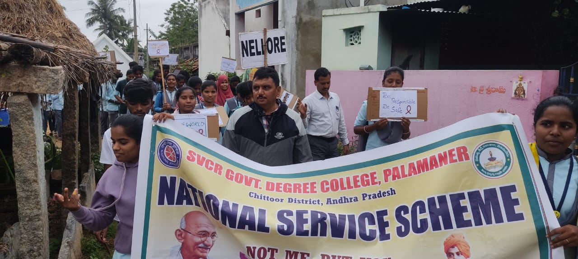
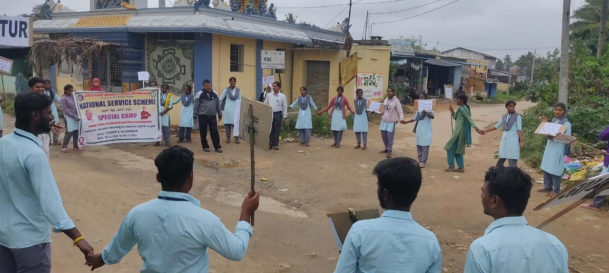
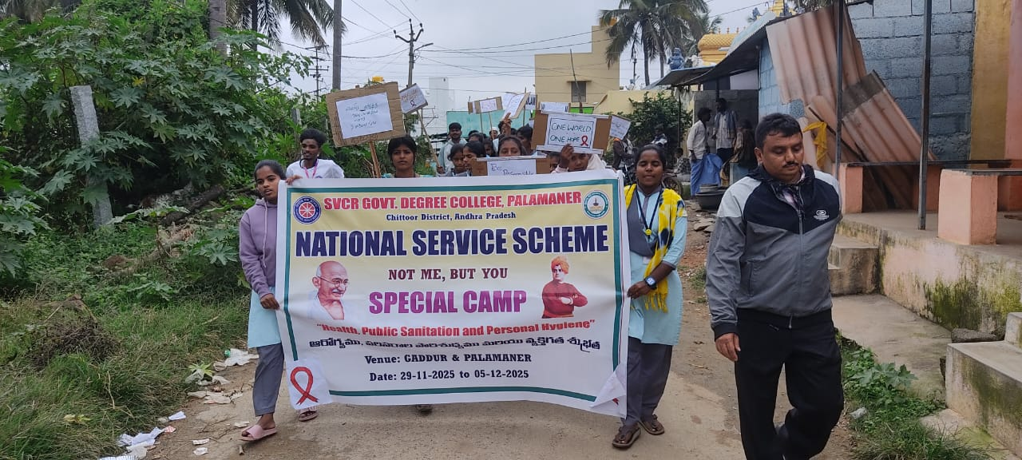
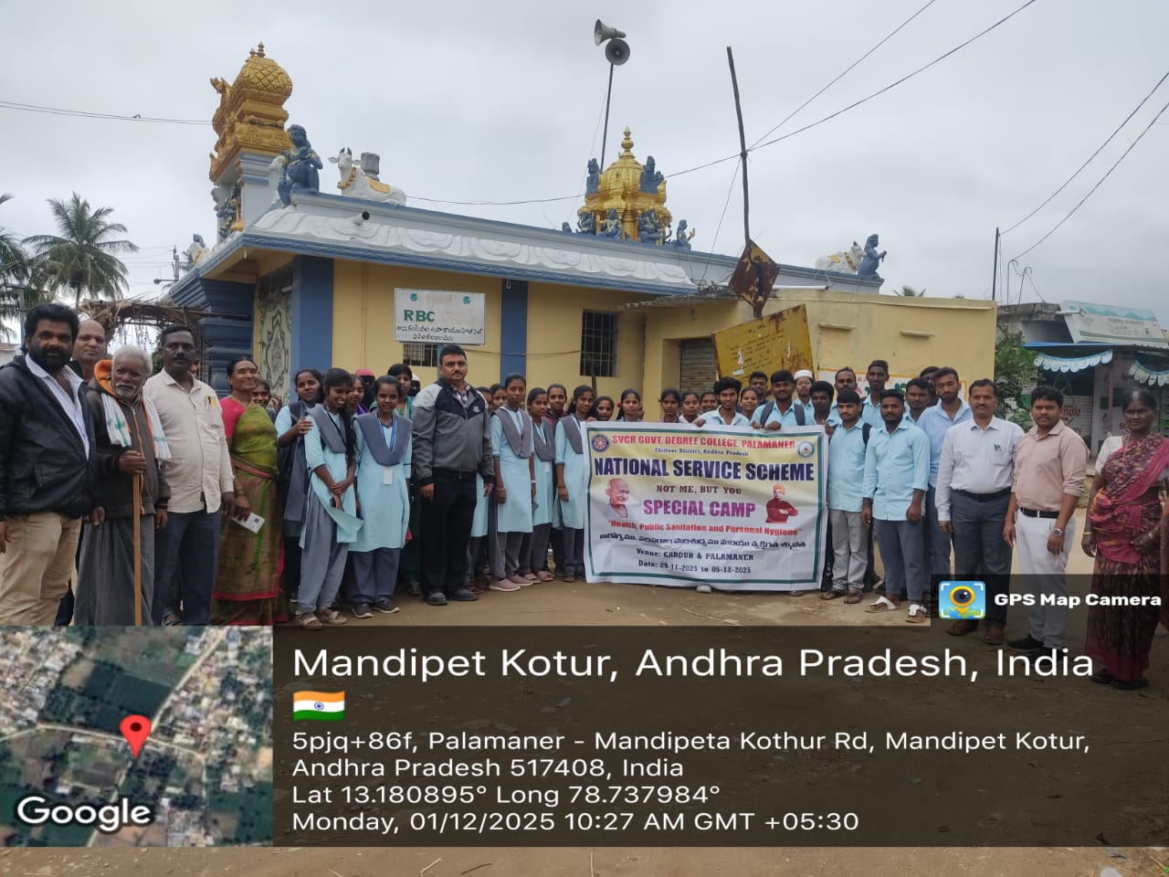
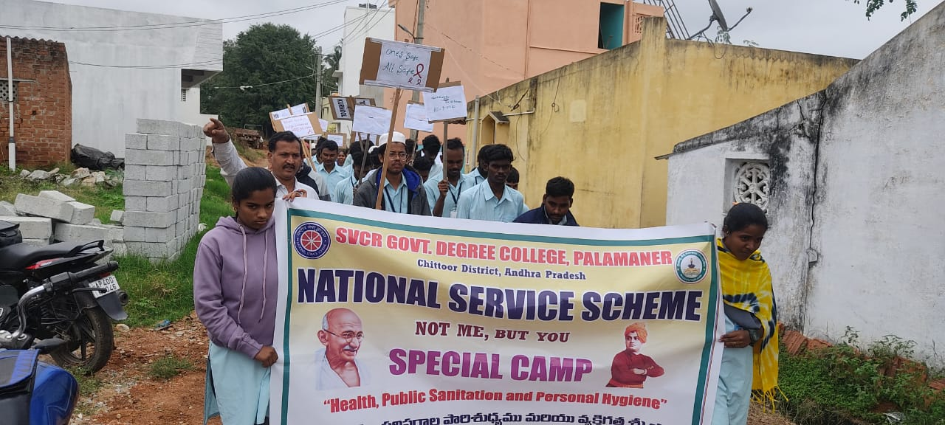

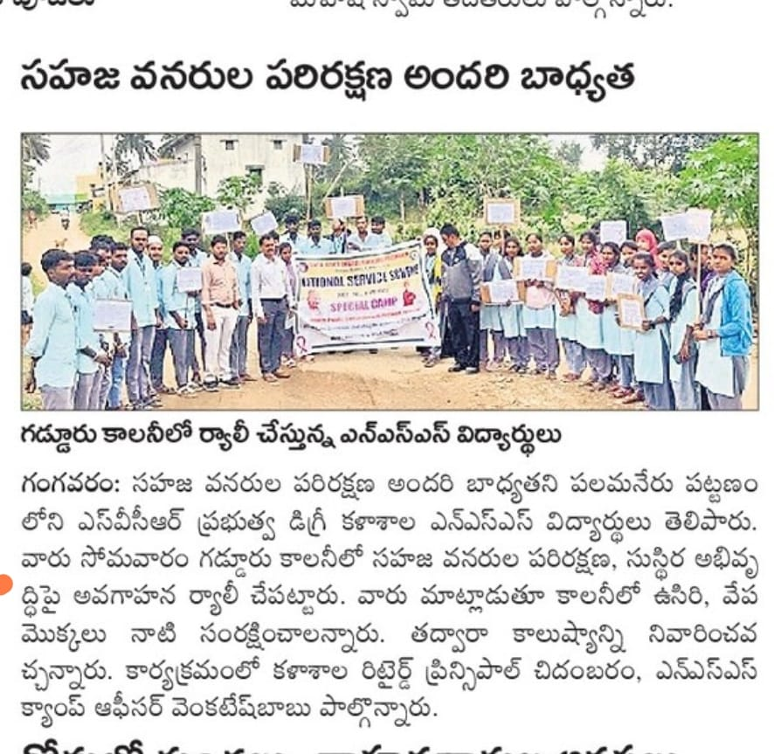

ADIS DAY
01.12.2025
Report on HIV & AIDS (ADIS) Awareness Programme
An HIV & AIDS (ADIS) Awareness Programme was conducted at the college campus to educate students about the causes, prevention, and control of HIV & AIDS. The programme aimed to remove myths, reduce stigma, and promote healthy and responsible behavior among students.
During the programme, faculty members explained the meaning of HIV and AIDS, modes of transmission, preventive measures, and the importance of early testing and treatment. Students were also made aware that HIV does not spread through casual contact and that people living with HIV should be treated with dignity and respect.
The programme created awareness among students about safe practices, social responsibility, and the importance of compassion toward affected individuals. The event concluded successfully with active participation from students and faculty members.
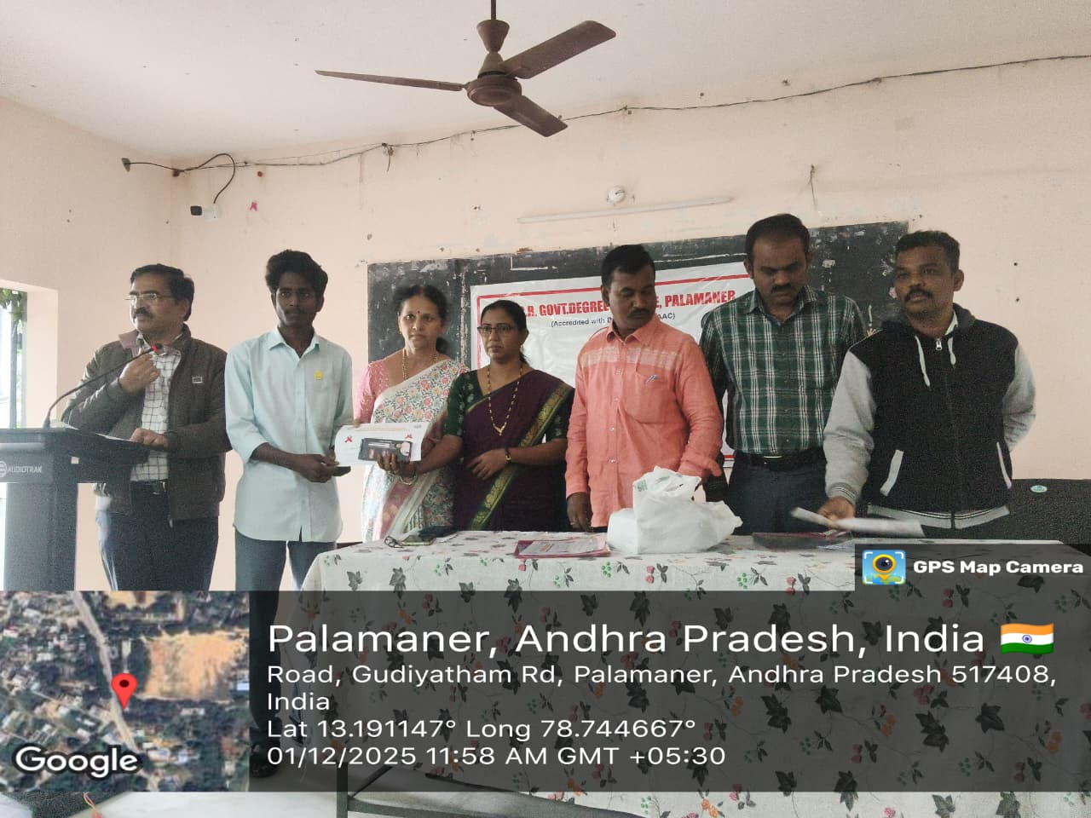
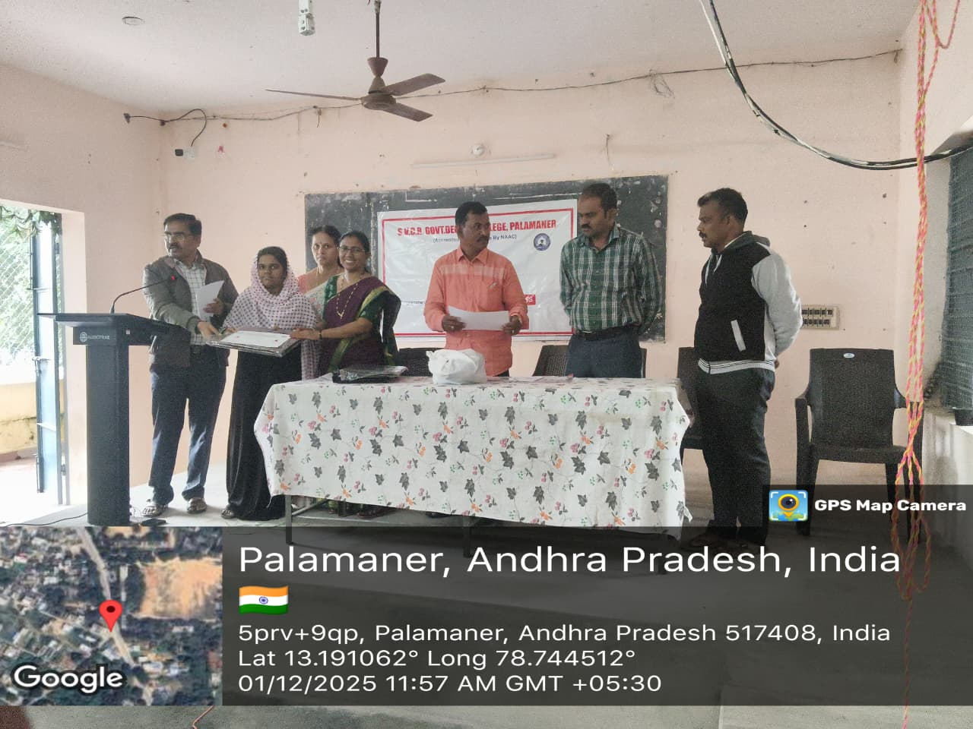
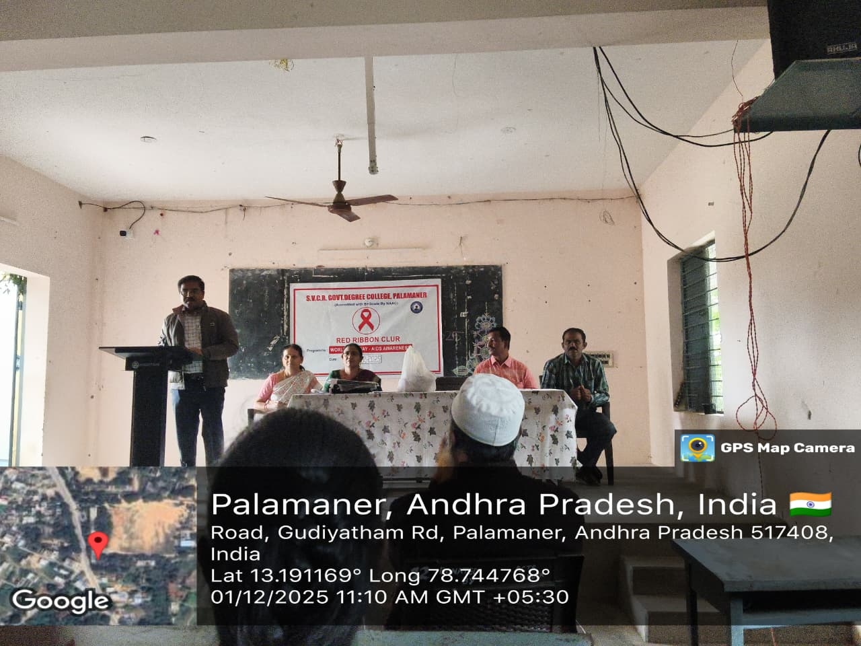
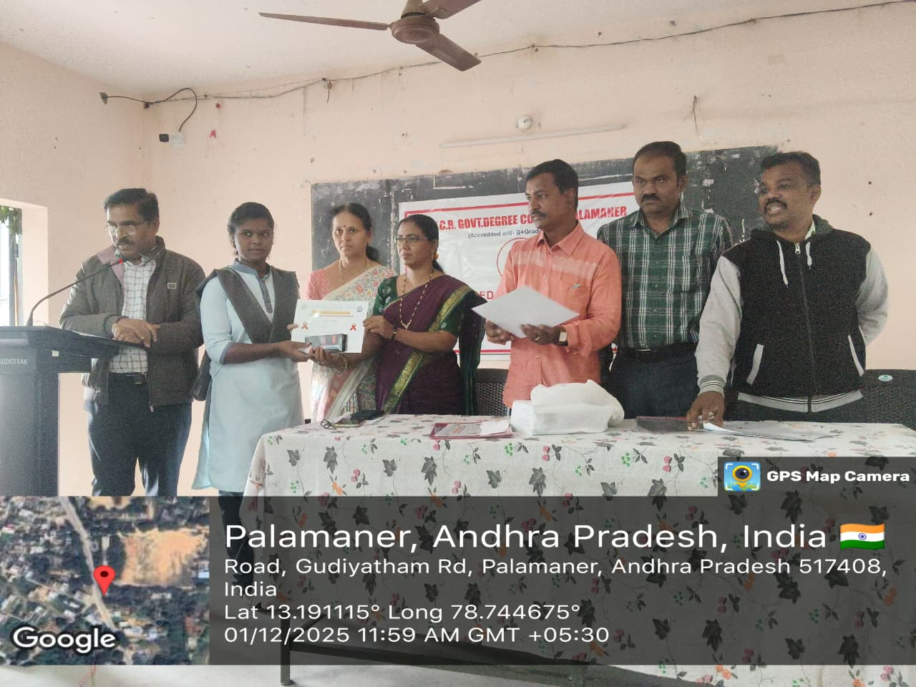
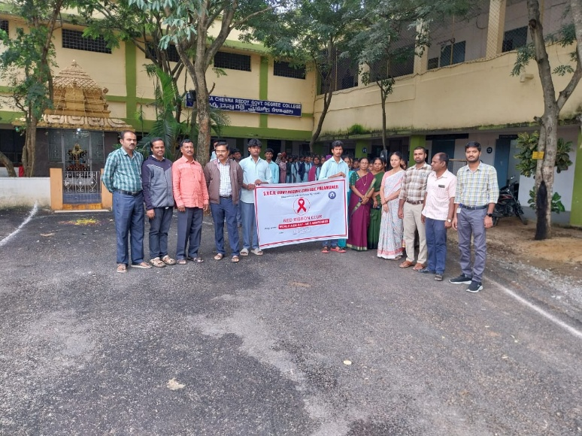

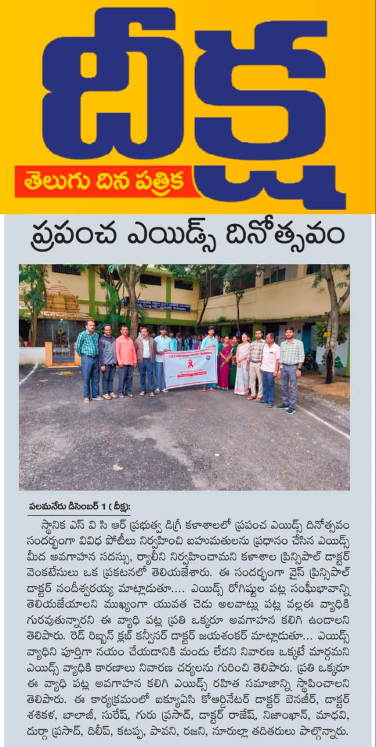
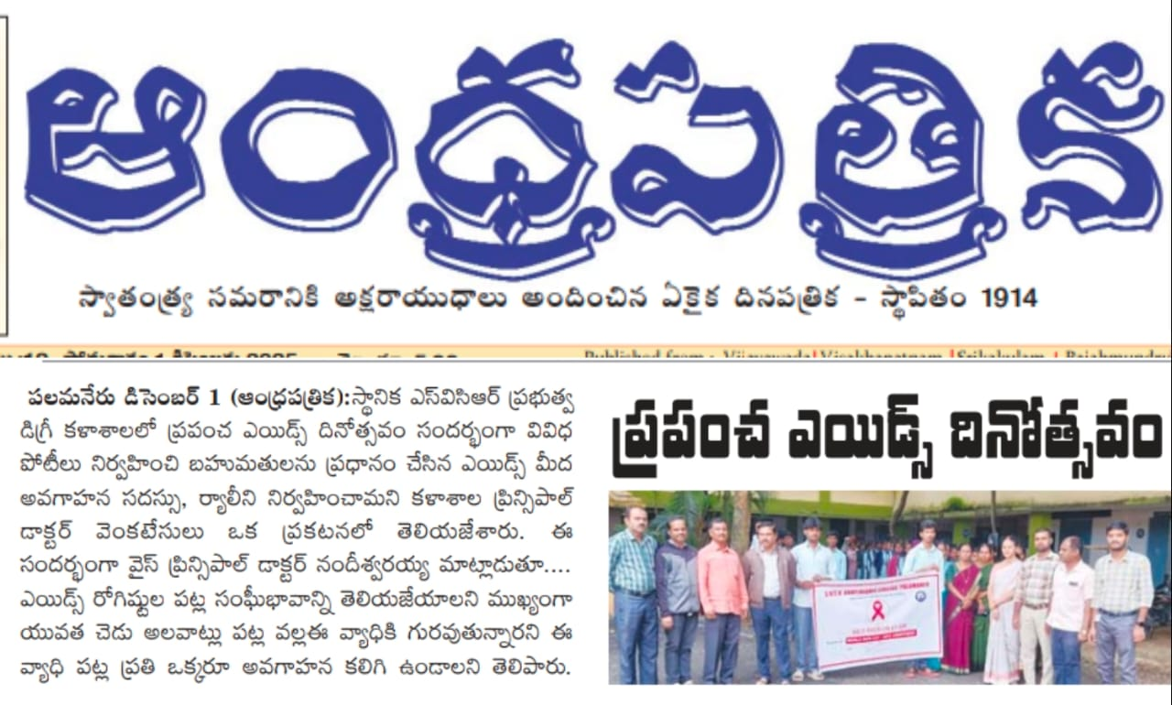
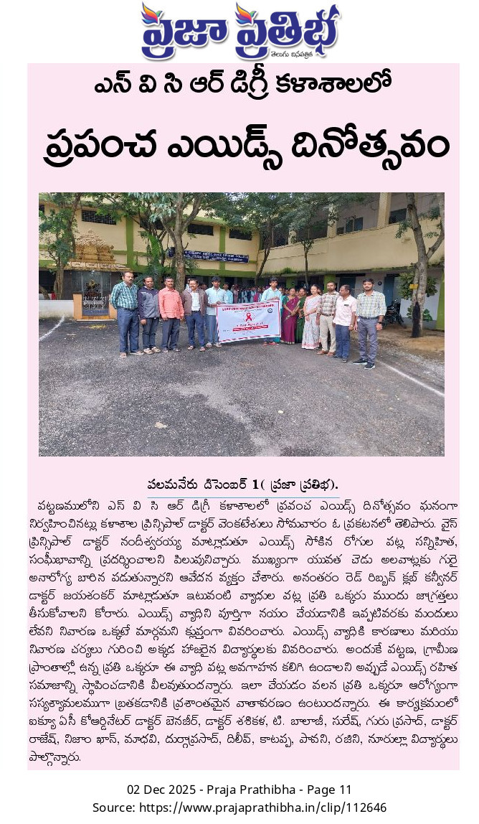
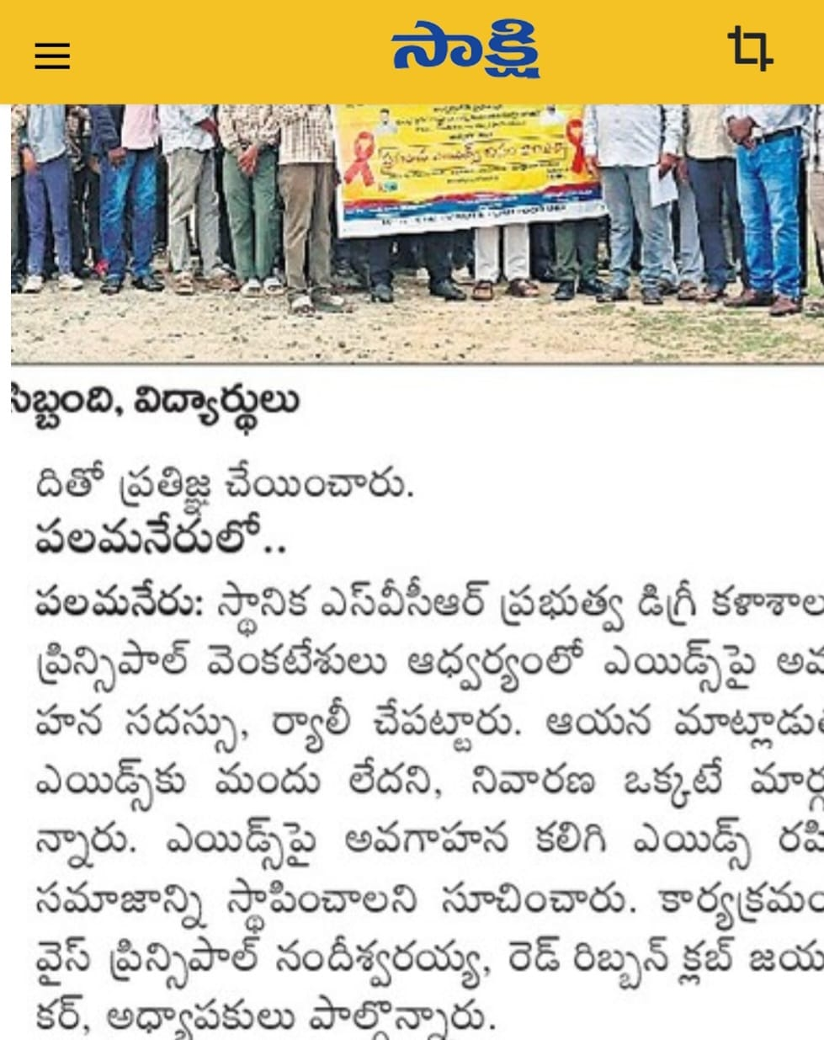

HEALTH CAMP CONDUCTED AT GADDUR VILLAGE
02.12.2025
Report on Health Camp Conducted at Gaddur Village
As part of the NSS Camp, a Health Camp was conducted at Gaddur Village with the objective of promoting health awareness and providing basic medical services to the villagers.
During the camp, doctors and medical staff conducted general health check-ups, including blood pressure, sugar level, and basic health examinations. The villagers were educated about personal hygiene, nutrition, sanitation, and the importance of regular health check-ups.
NSS volunteers actively assisted the medical team and helped in organizing the camp smoothly. The villagers made good use of the services provided and appreciated the efforts of the NSS students.
The health camp was conducted successfully and contributed to improving health awareness and well-being among the rural population.

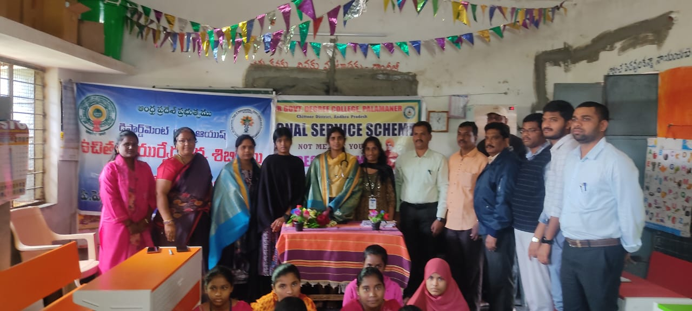

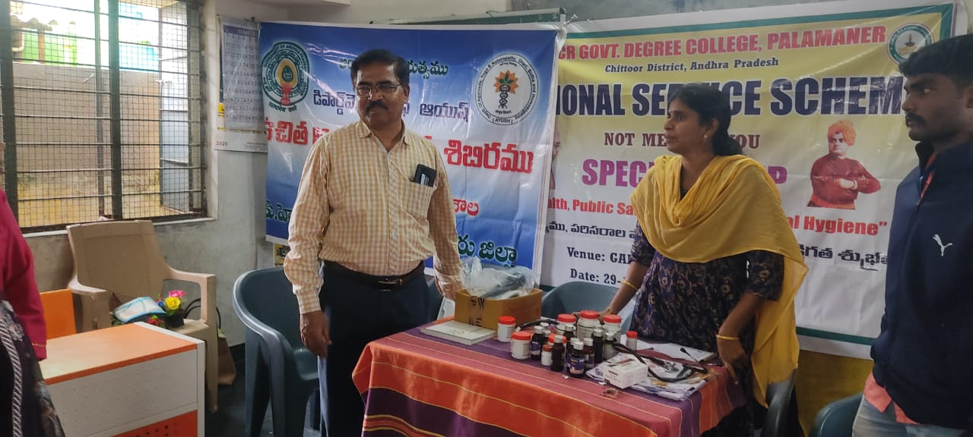
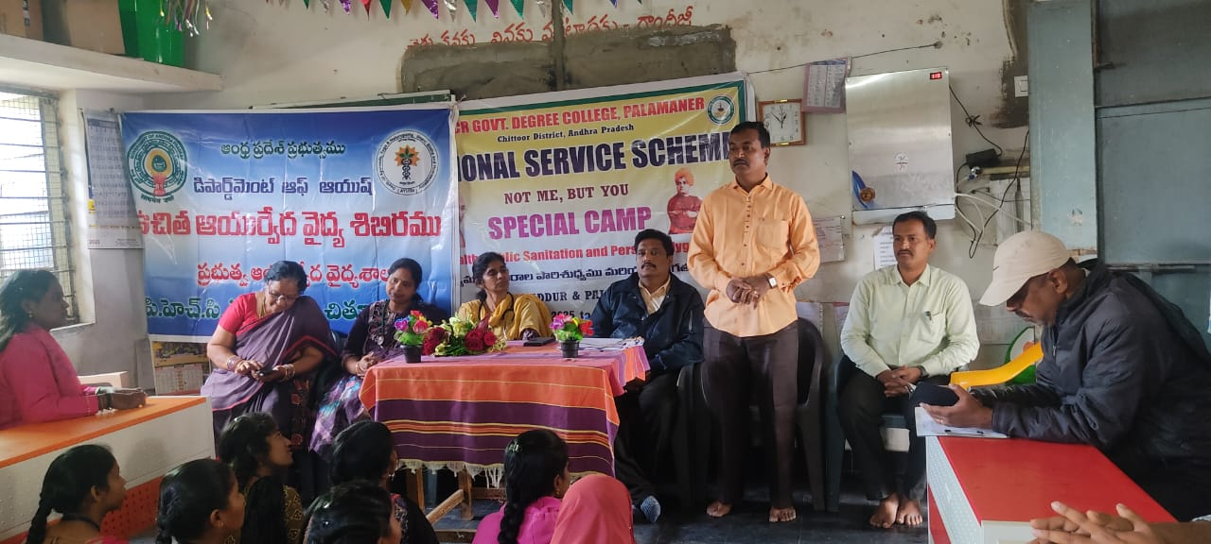
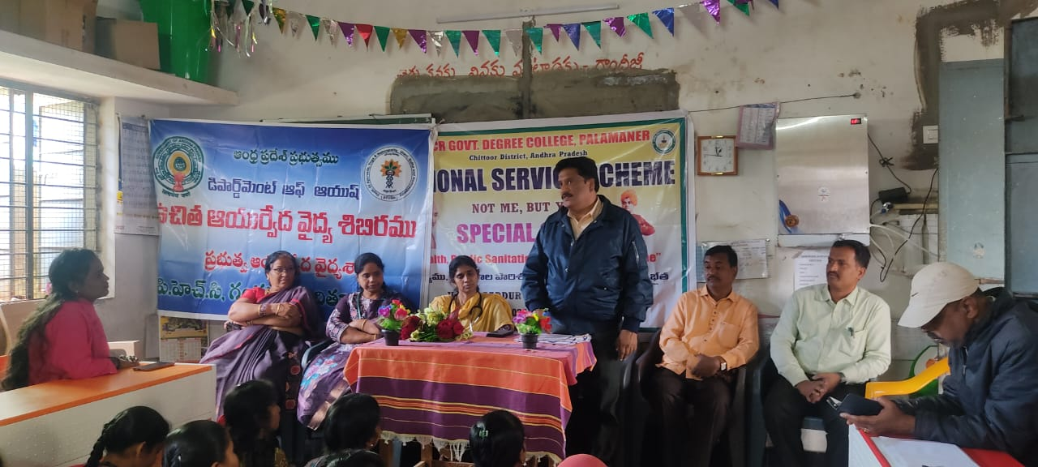
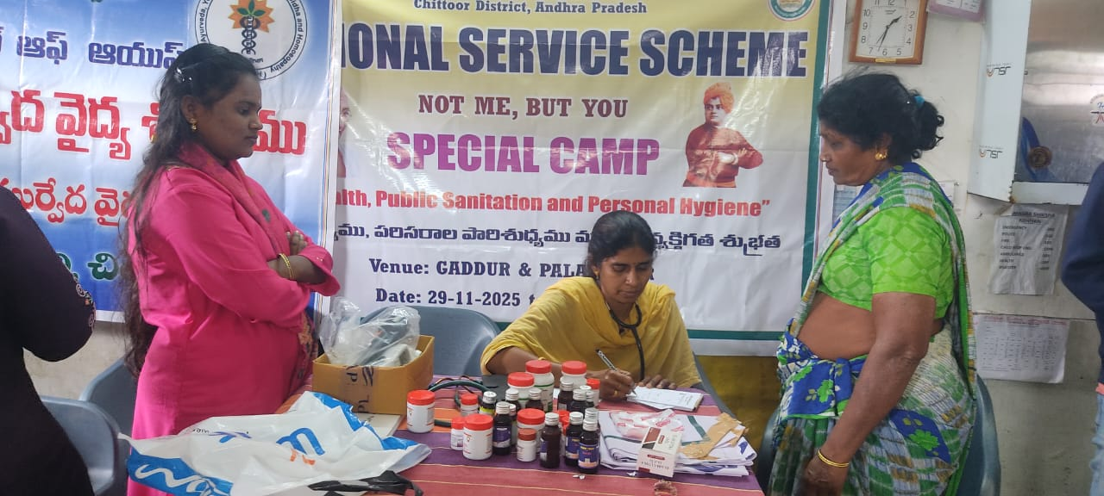
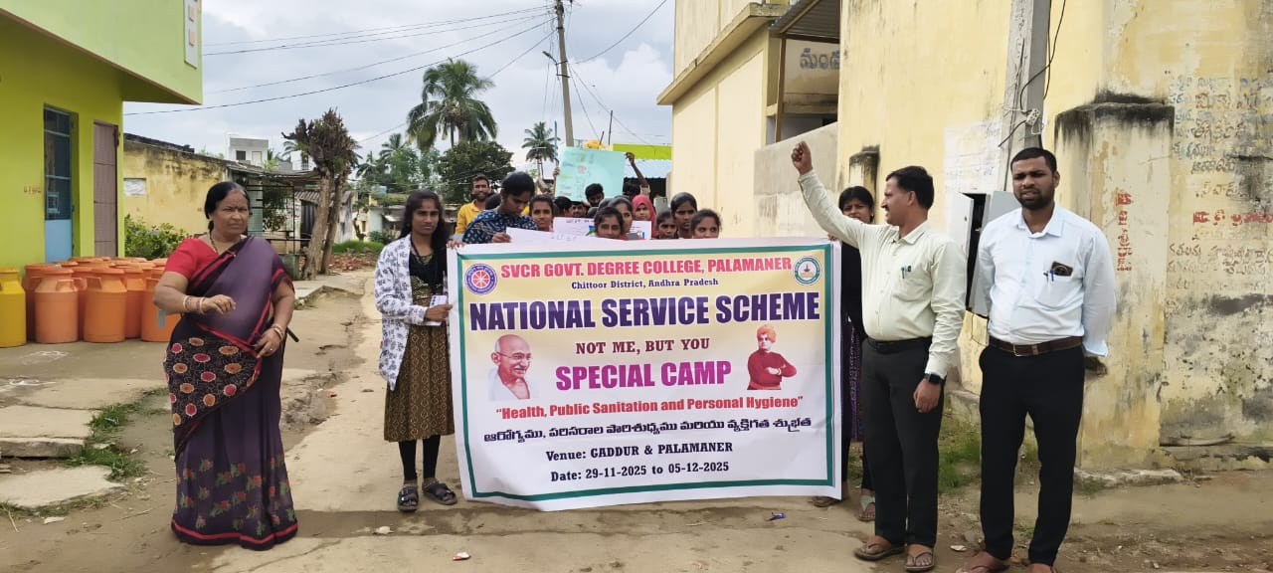

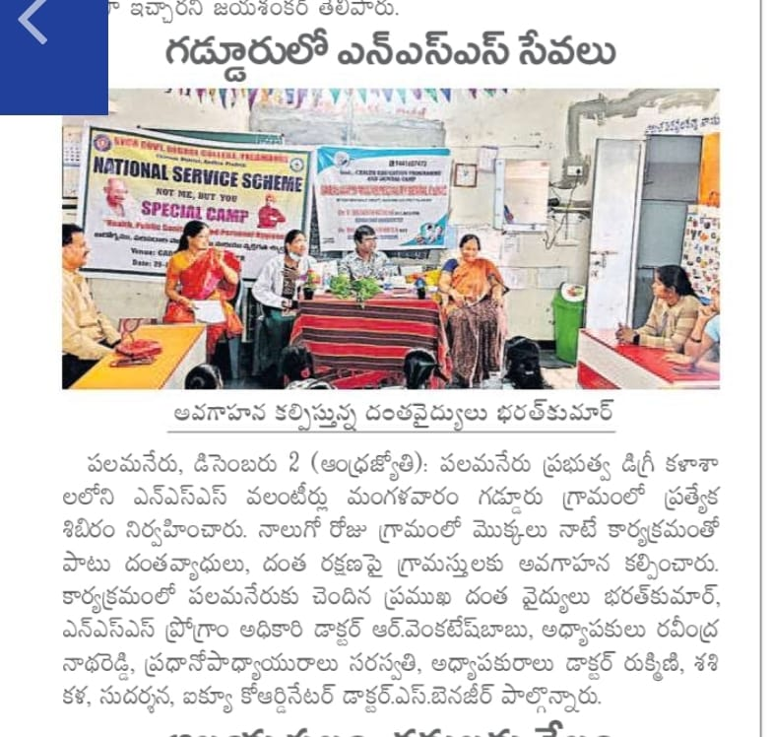

Report on Selection of Student for SV University Volleyball Team
02.12.2025

It is a matter of great pride that Mr. Sameer, a student of B.Com Final Year from our college, has been selected for the SV University Volleyball Team. His selection reflects his dedication, discipline, and outstanding performance in the game of volleyball.
Sameer has consistently shown excellence in sports and actively participated in various inter-collegiate tournaments. Through hard work and regular practice, he earned this prestigious opportunity to represent SV University at the university level.
The college management, faculty members, and students congratulated Sameer on his achievement and wished him success in future competitions. His selection serves as an inspiration to other students to excel not only in academics but also in sports.

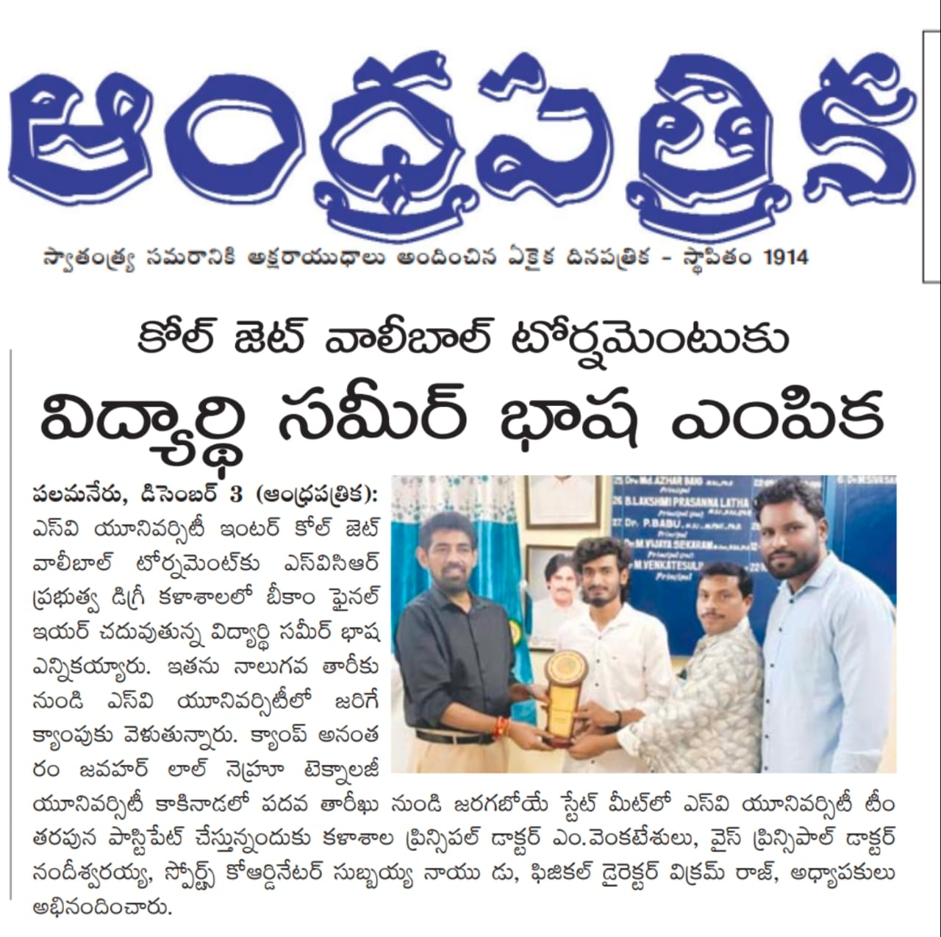
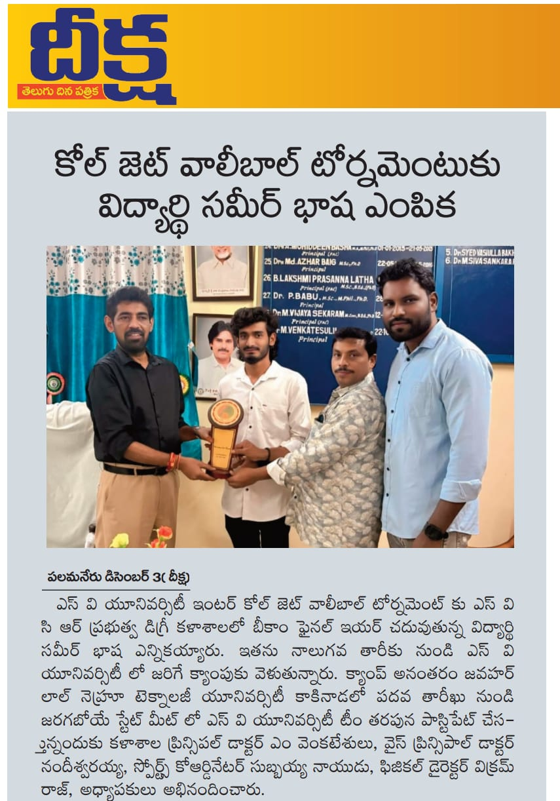
ANIMAL SANITATION PROGRAMME AT GADDUR VILLAGE
04.12.2025

Report on Animal Sanitation Programme at Gaddur Village
The NSS students organized an Animal Sanitation Programme at Gaddur Village with the aim of promoting cleanliness, animal health, and public hygiene in the village.
During the programme, students actively participated in cleaning cattle sheds, removing waste, and spreading awareness among villagers about maintaining hygienic surroundings for domestic animals. The importance of proper sanitation, clean drinking water for animals, and regular health care was explained to the villagers.
The programme helped in improving awareness about animal hygiene and its role in preventing diseases. The villagers appreciated the efforts of the students. The activity was successful in creating a sense of responsibility and service among the students towards society and animal welfare.
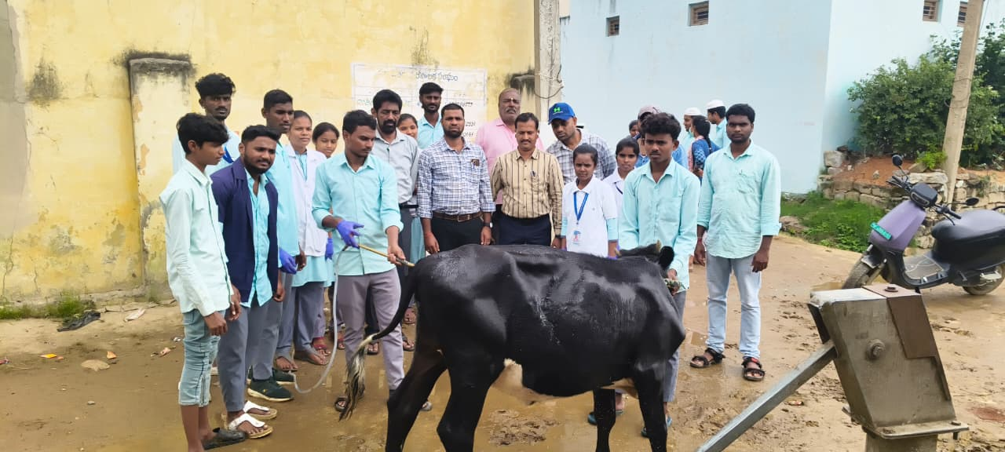
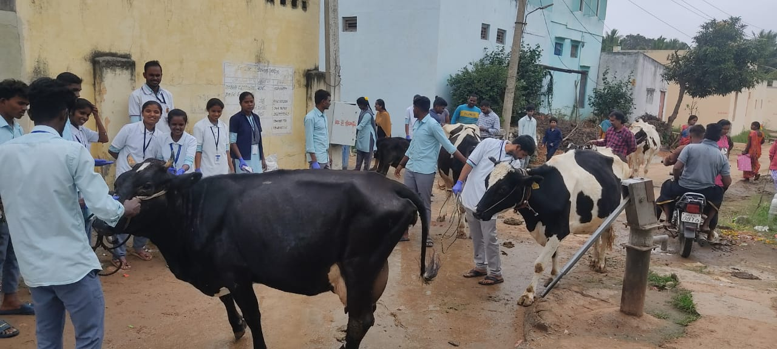
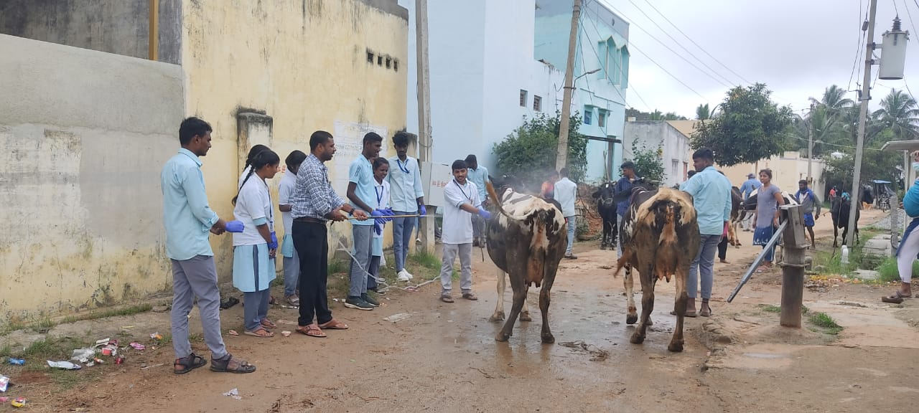
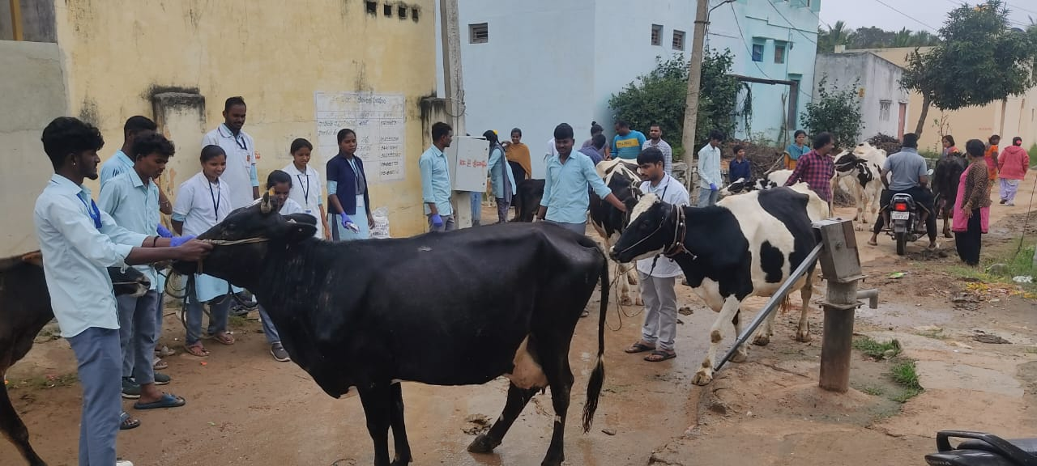
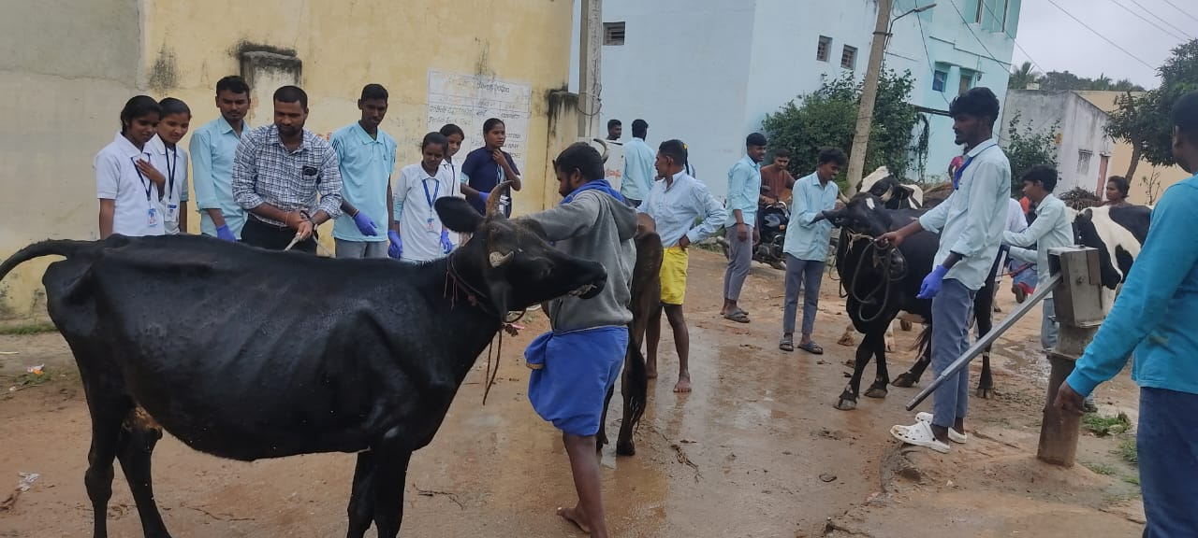
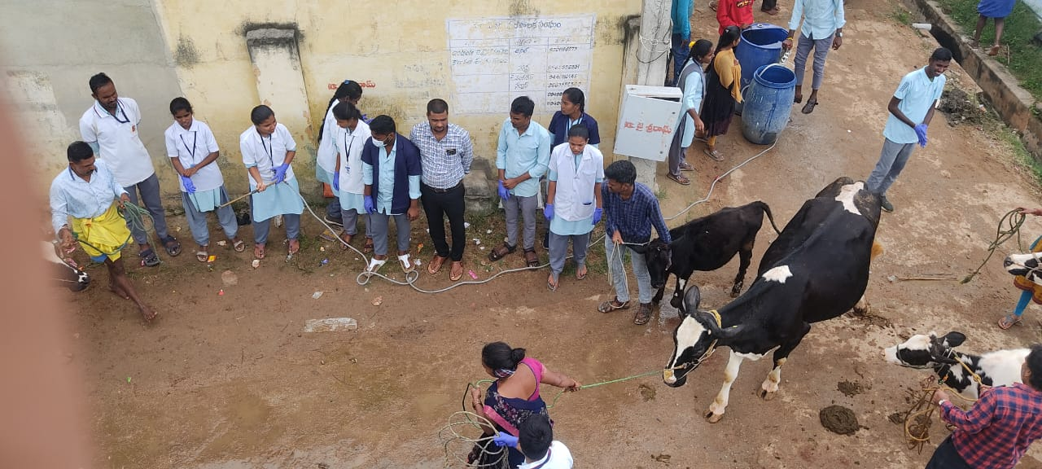

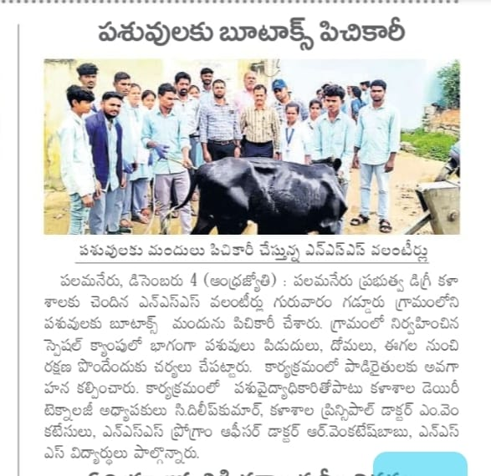

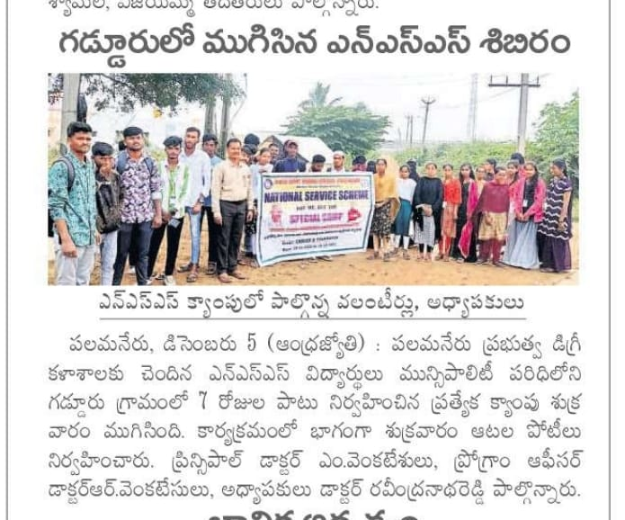

National Energy Conservation Day
15.12.2025

National Energy Conservation Day was observed at the college campus to create awareness among students about the importance of conserving energy and using resources responsibly. The programme aimed to educate students on energy saving practices and sustainable development.
On this occasion, faculty members addressed the students on the need to conserve electricity, reduce energy wastage, and adopt renewable energy sources. Students were encouraged to switch off lights and electrical appliances when not in use and to practice energy-efficient habits in their daily lives.
The programme helped students understand the significance of energy conservation for environmental protection and future generations. The observance of National Energy Conservation Day concluded successfully with active participation from students and staff members.

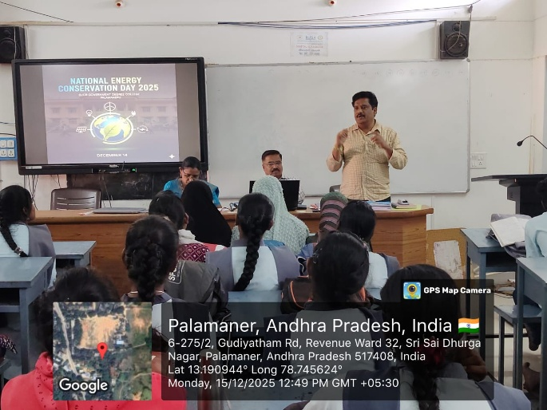
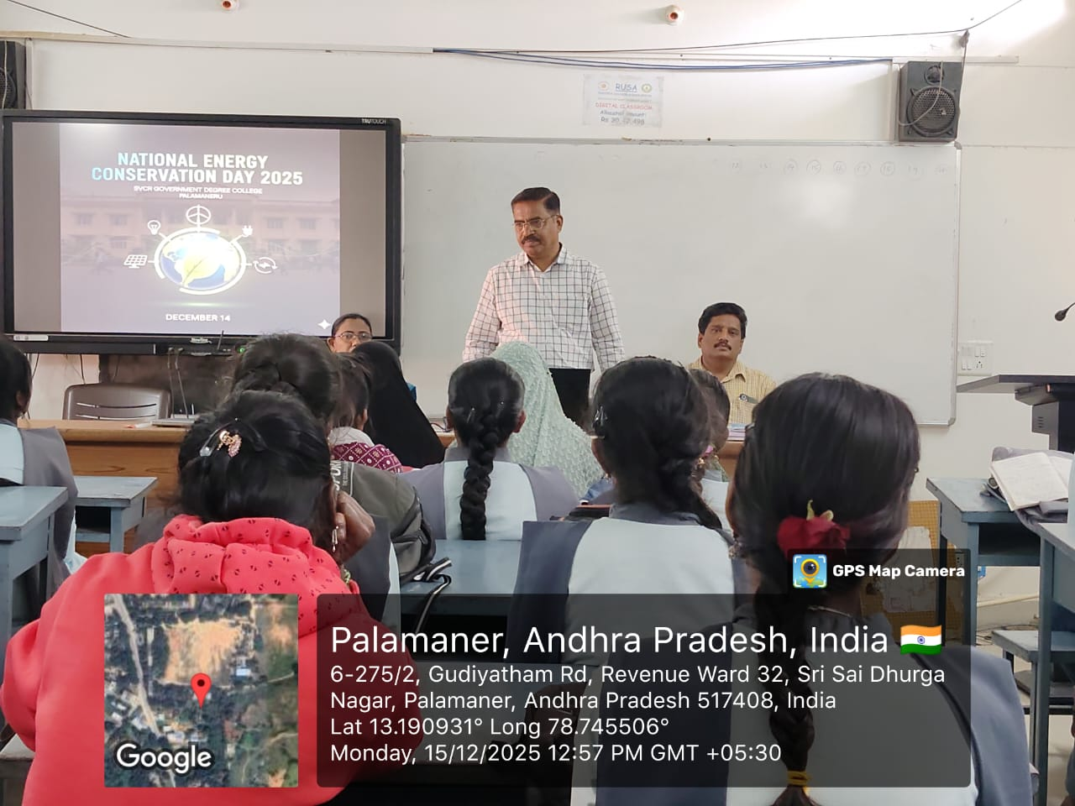

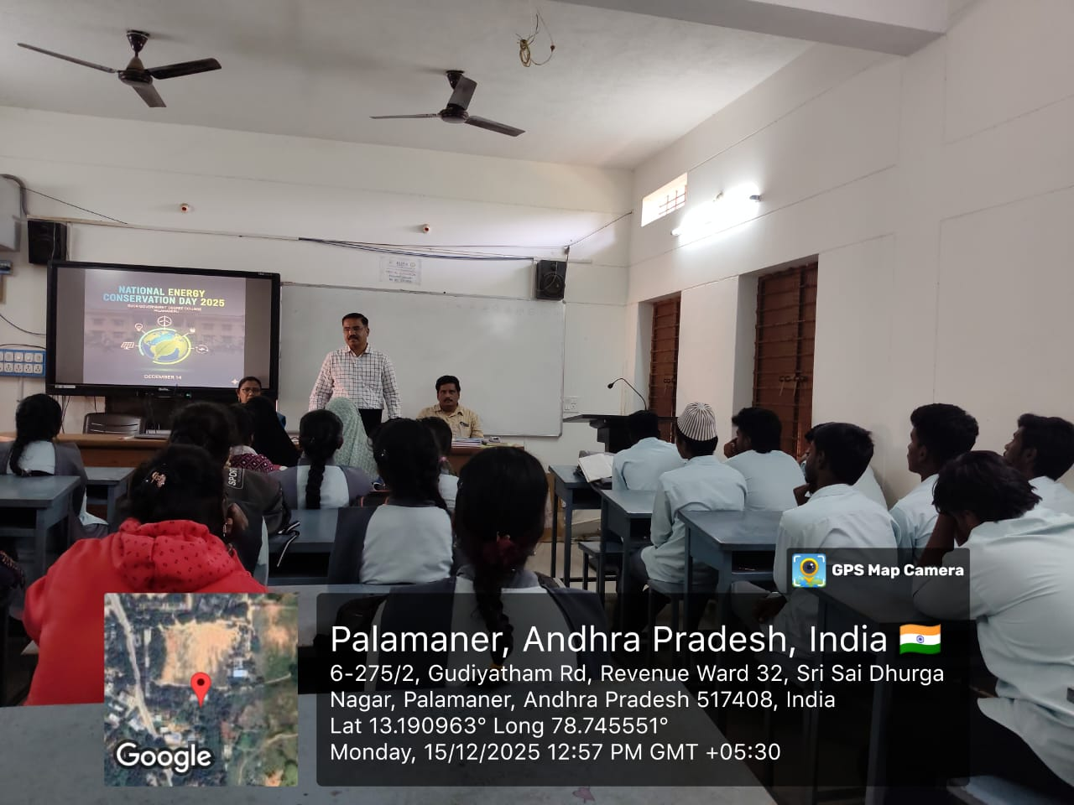
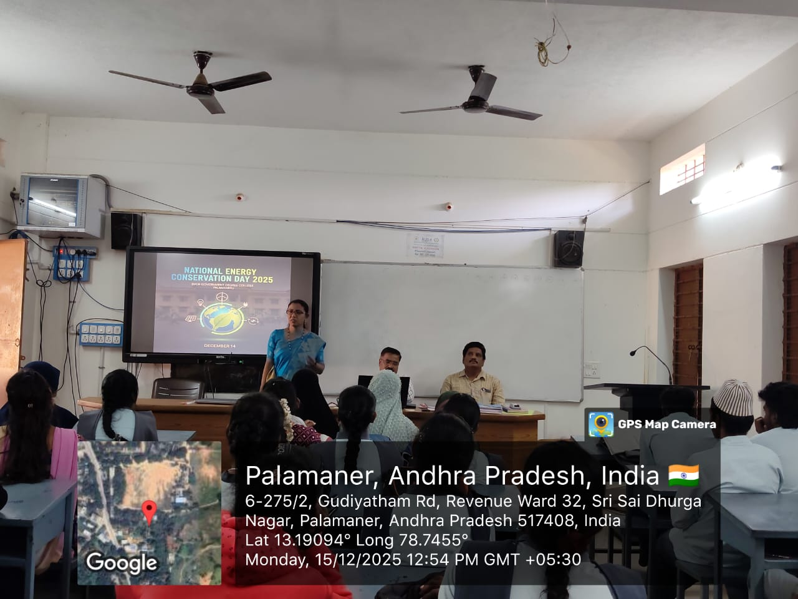

Online Quiz Occasion of National Mathematics Day
22.12.2025

On the auspicious occasion of National Mathematics Day, commemorating the birth anniversary of the legendary mathematician Srinivasa Ramanujan, the Department of Mathematics is pleased to organize an Online Quiz as part of the celebrations. We cordially invite you and your students to participate in this quiz. E-Certificates of Participation will be generated and sent to the registered email IDs.
🔗 Quiz Link:
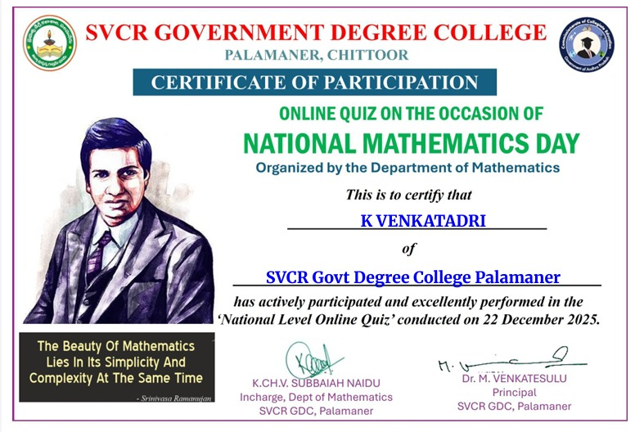
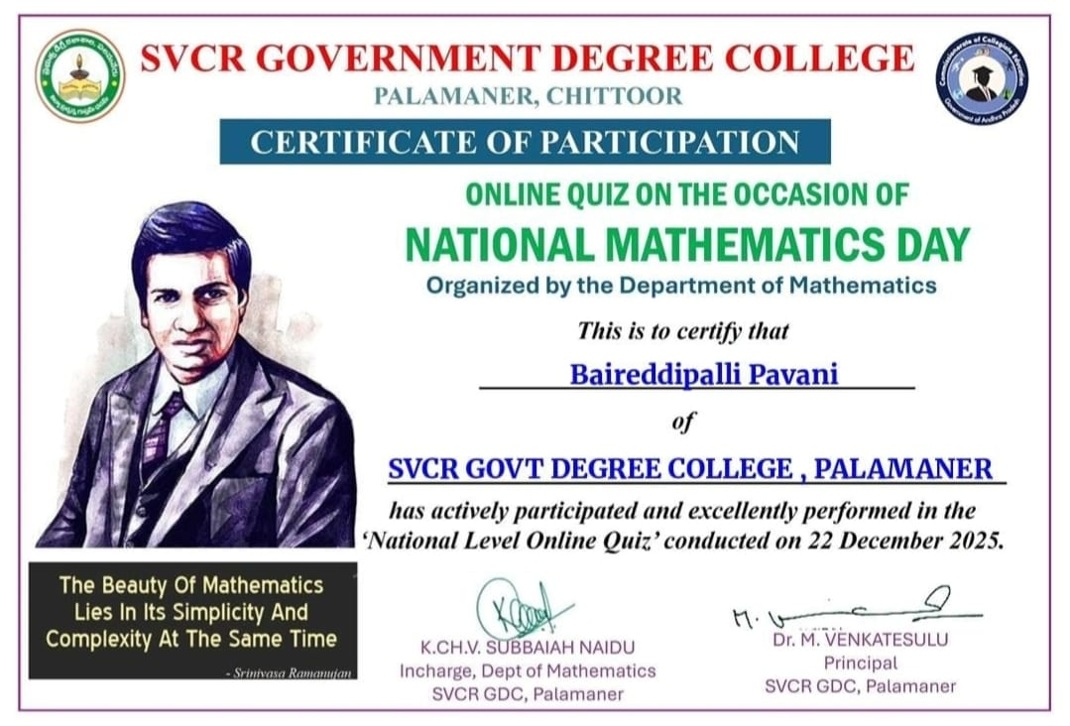
https://forms.gle/2NvmEntt9h5nGS3z6
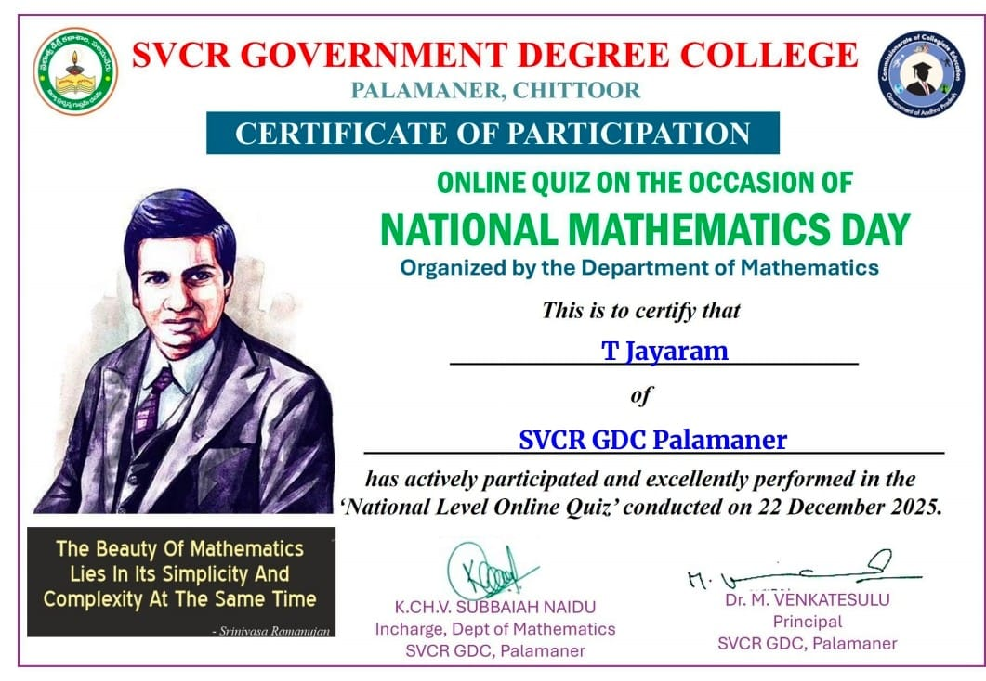
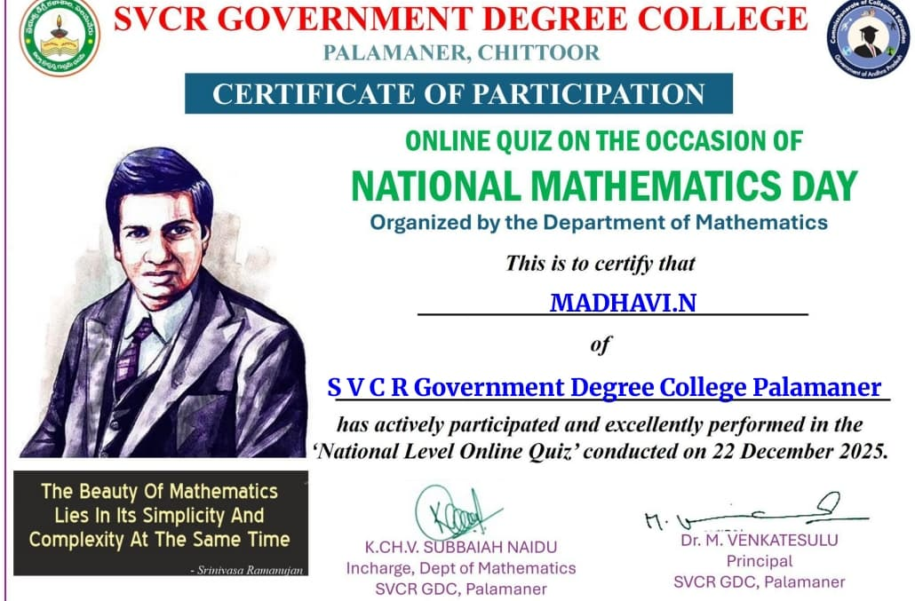

NATIONAL MATHEMATICS DAY
22.12.2025
Dept. of Maths, SVCR GDC, Palamaner celebrated National Mathematics Day to commemorate the birth anniversary of the great mathematician Srinivasa Ramanujan. On this occasion, the Department of Mathematics organized various academic activities to promote interest and awareness in Mathematics among students. The activities included an Essay Writing Competition on the topic “Greatness and Achievements of Srinivasa Ramanujan” and an Objective Examination covering Arithmetic, Quantitative Aptitude, and Current Affairs. Students actively participated and showcased their knowledge and analytical skills. An Online Quiz was also conducted as part of the celebrations, encouraging wider student participation. The programme successfully highlighted the importance of Mathematics in everyday life and inspired students to appreciate the legacy of Srinivasa Ramanujan.
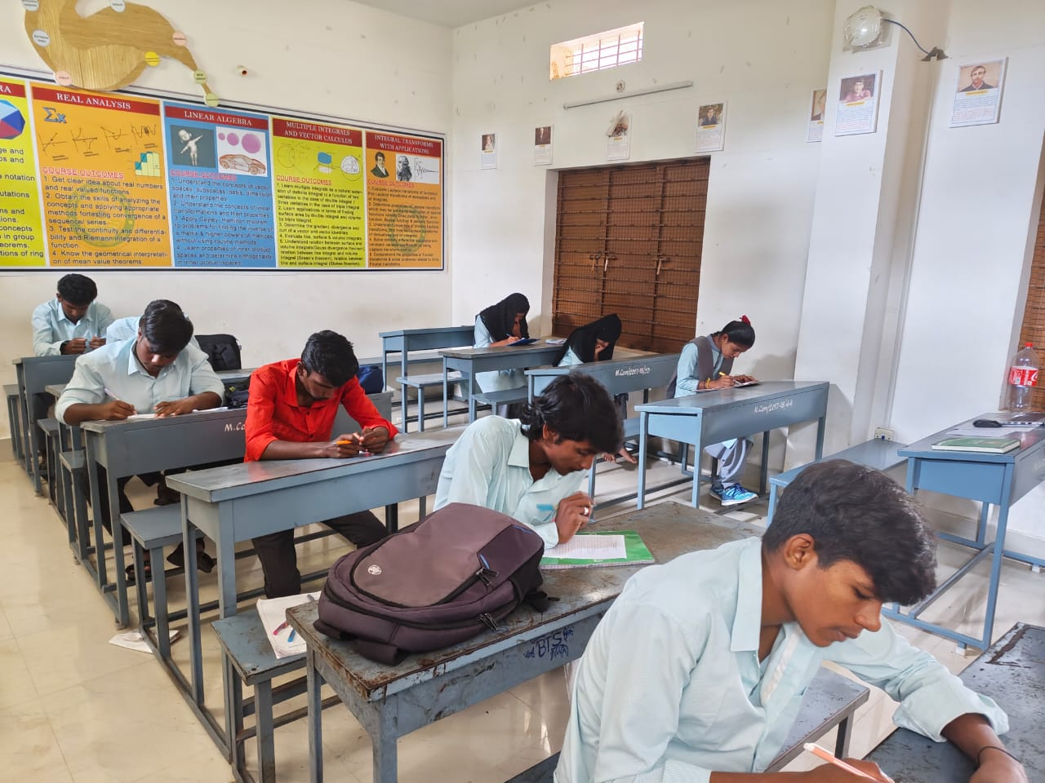
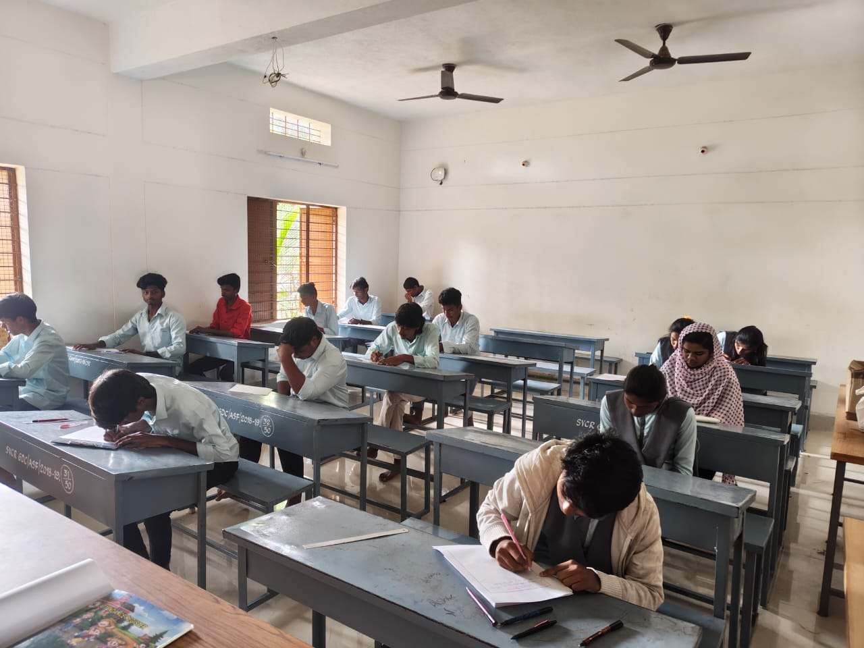
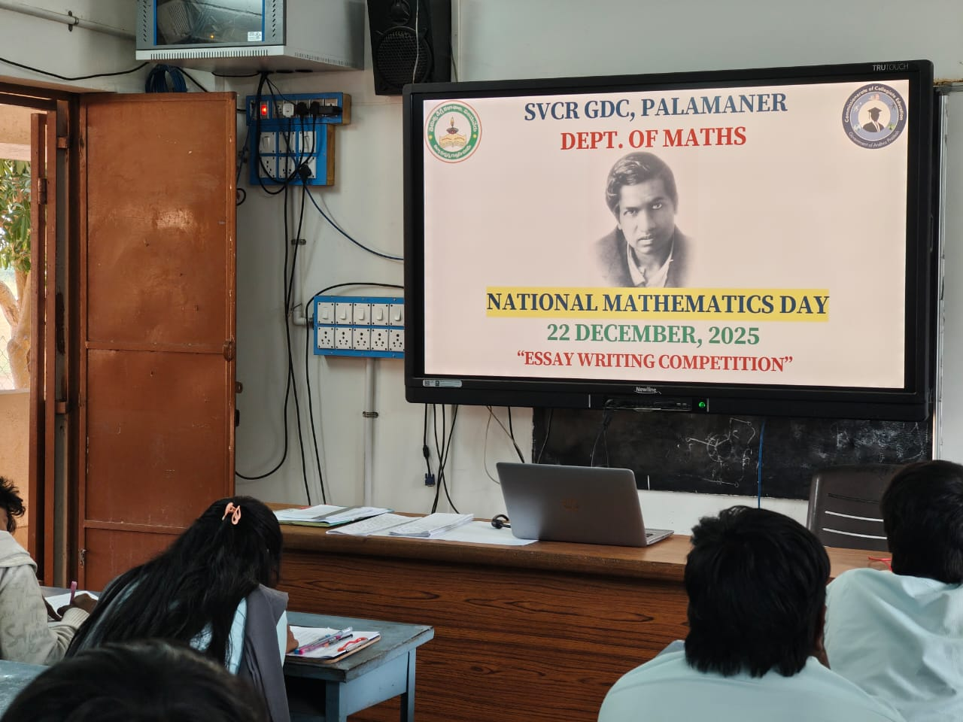
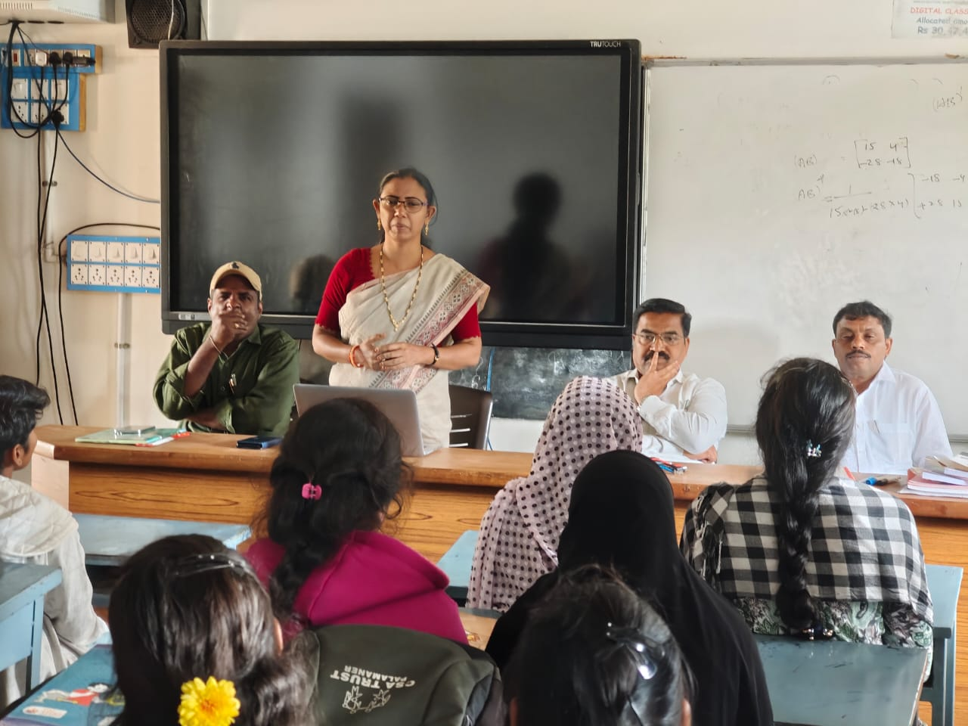
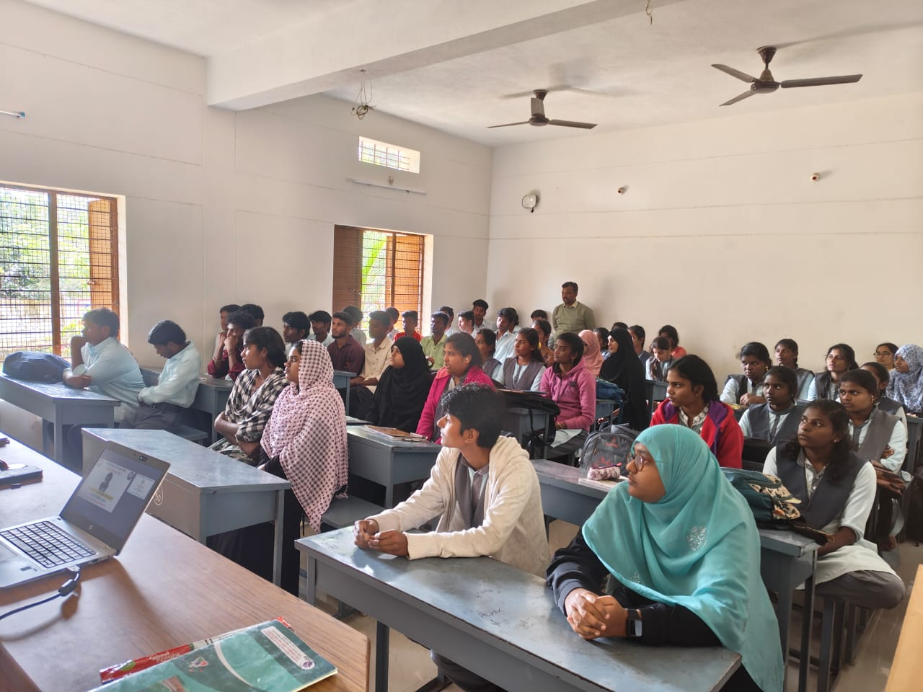
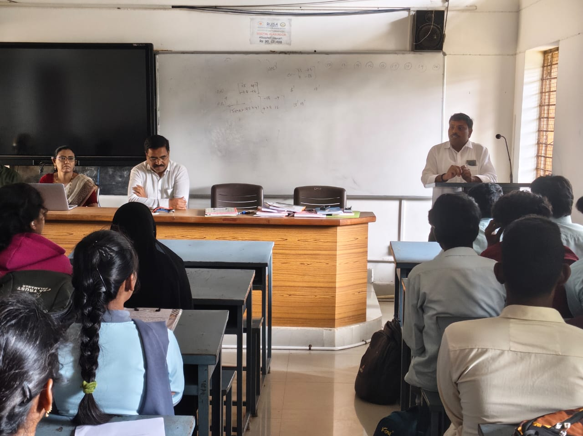
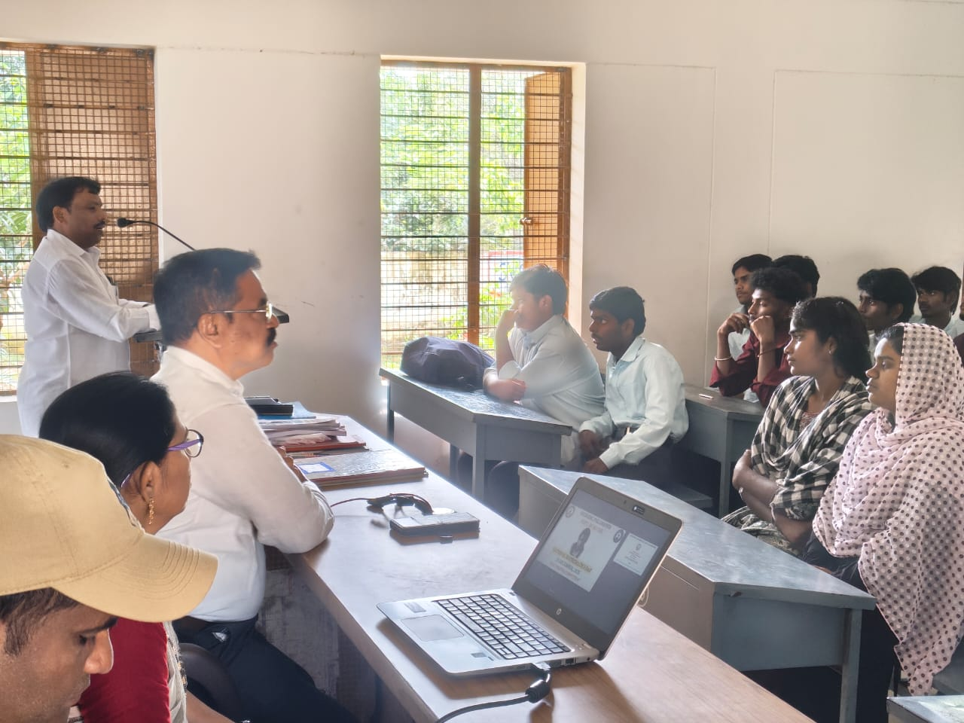
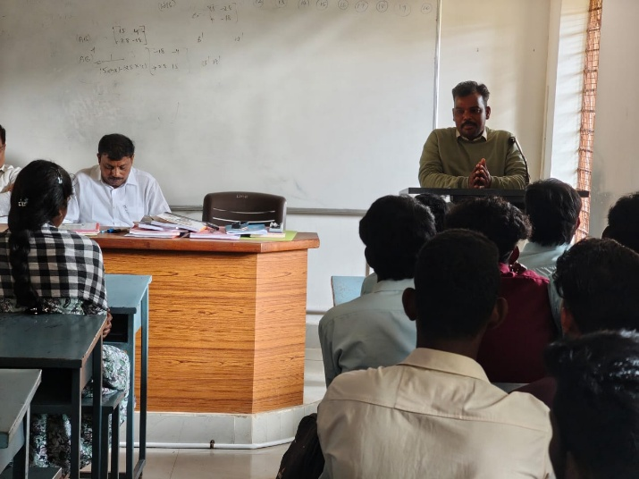
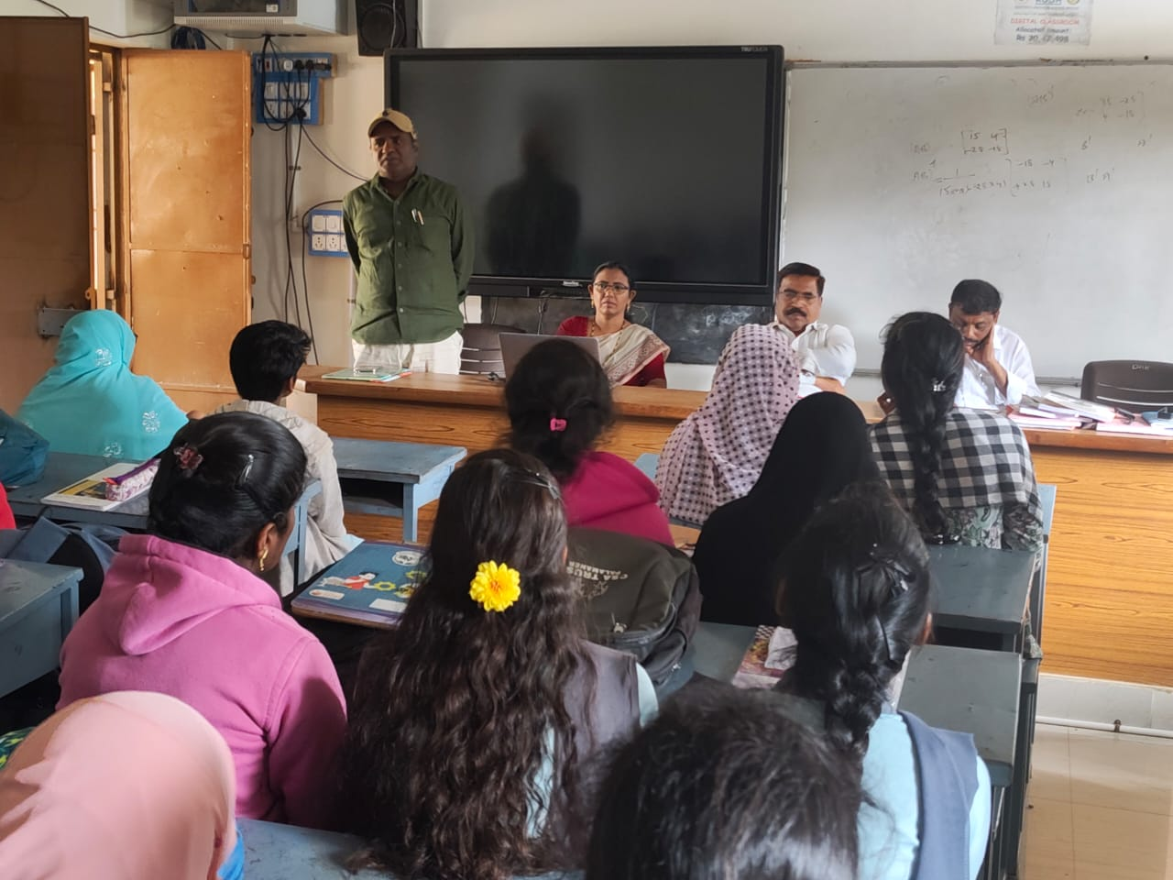

QUANTUM TALK BY HCM SRI NARA CHANDRABABU NAIDU GARU
23.12.2025
LINK
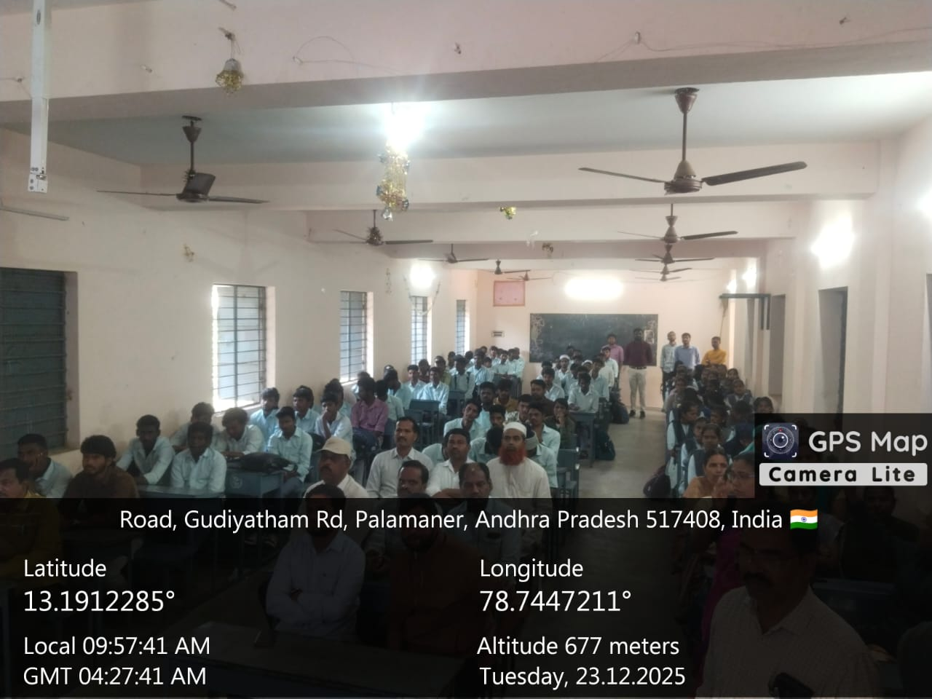
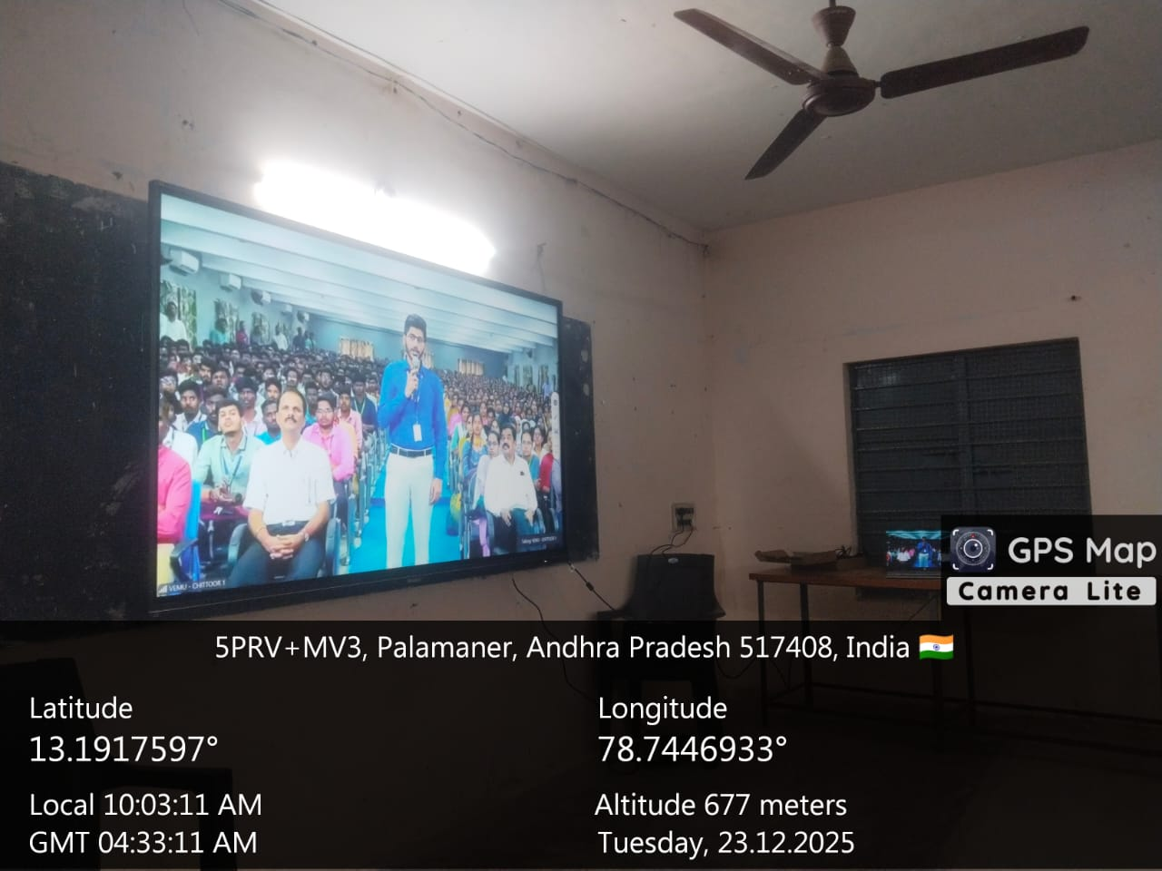
https://youtube.com/live/8IjeAAN8pZM?feature=share
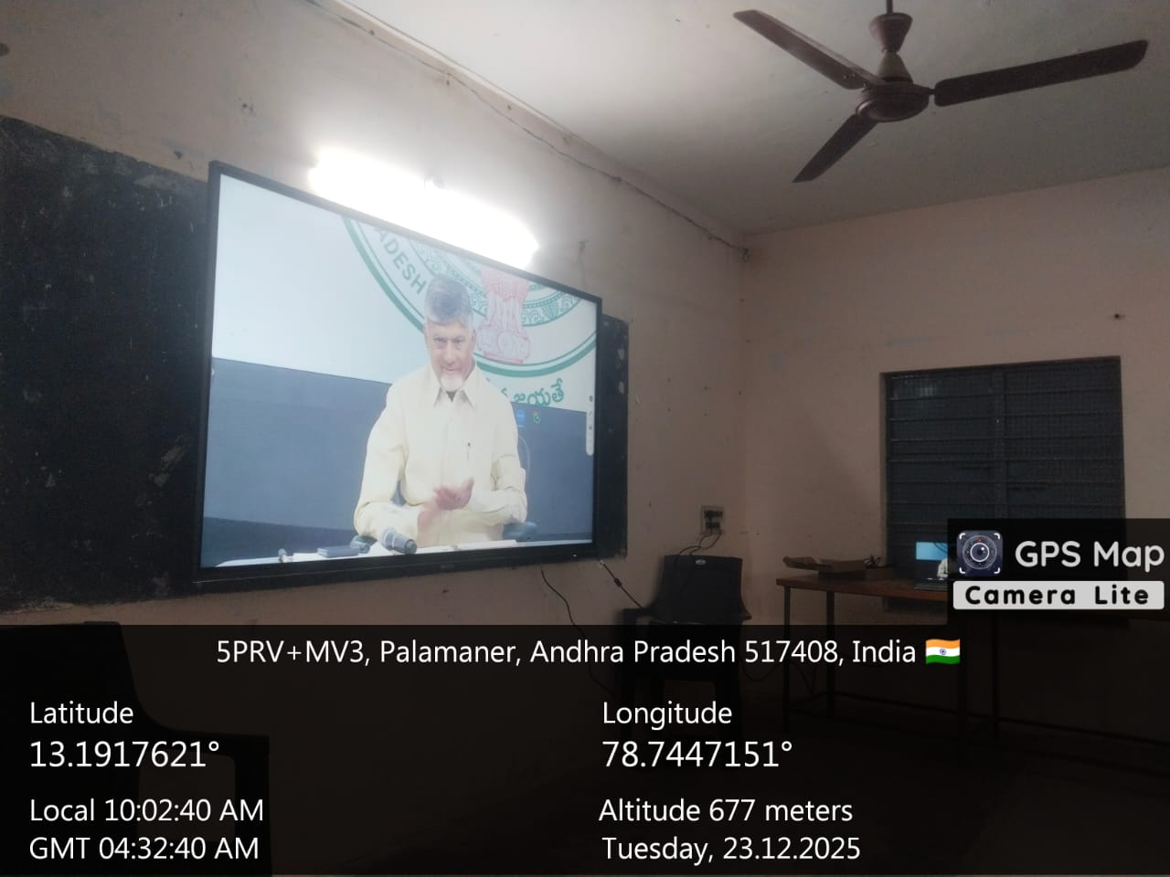
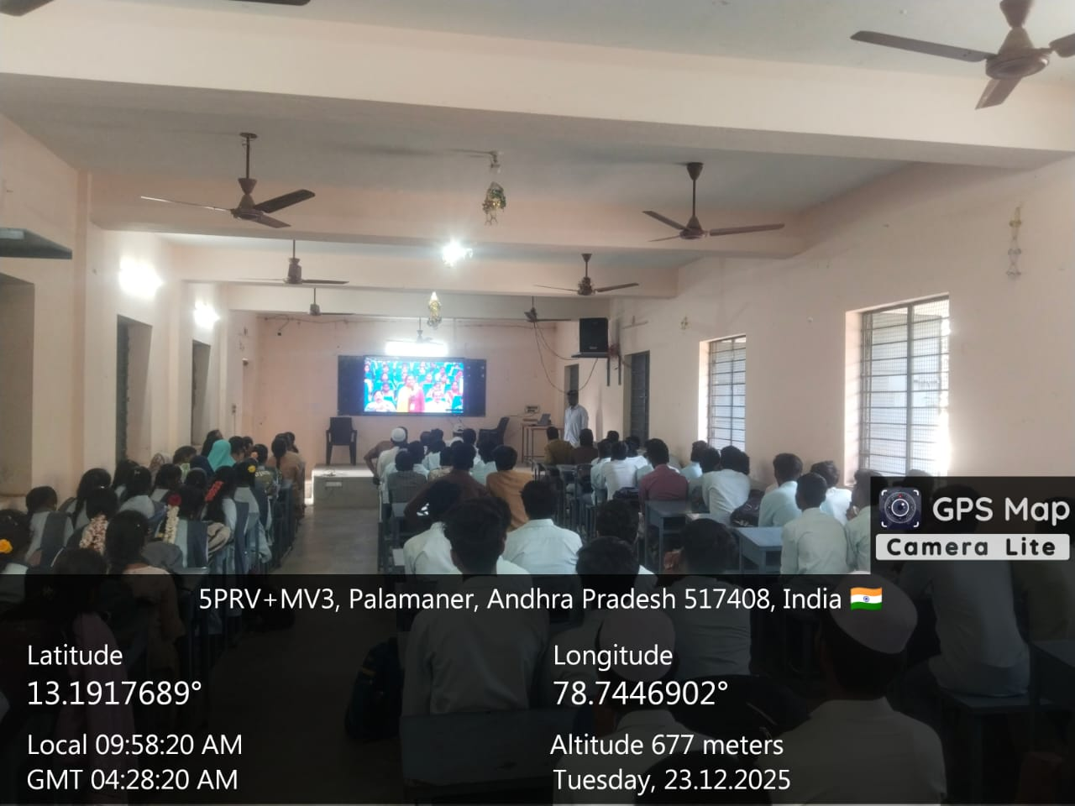

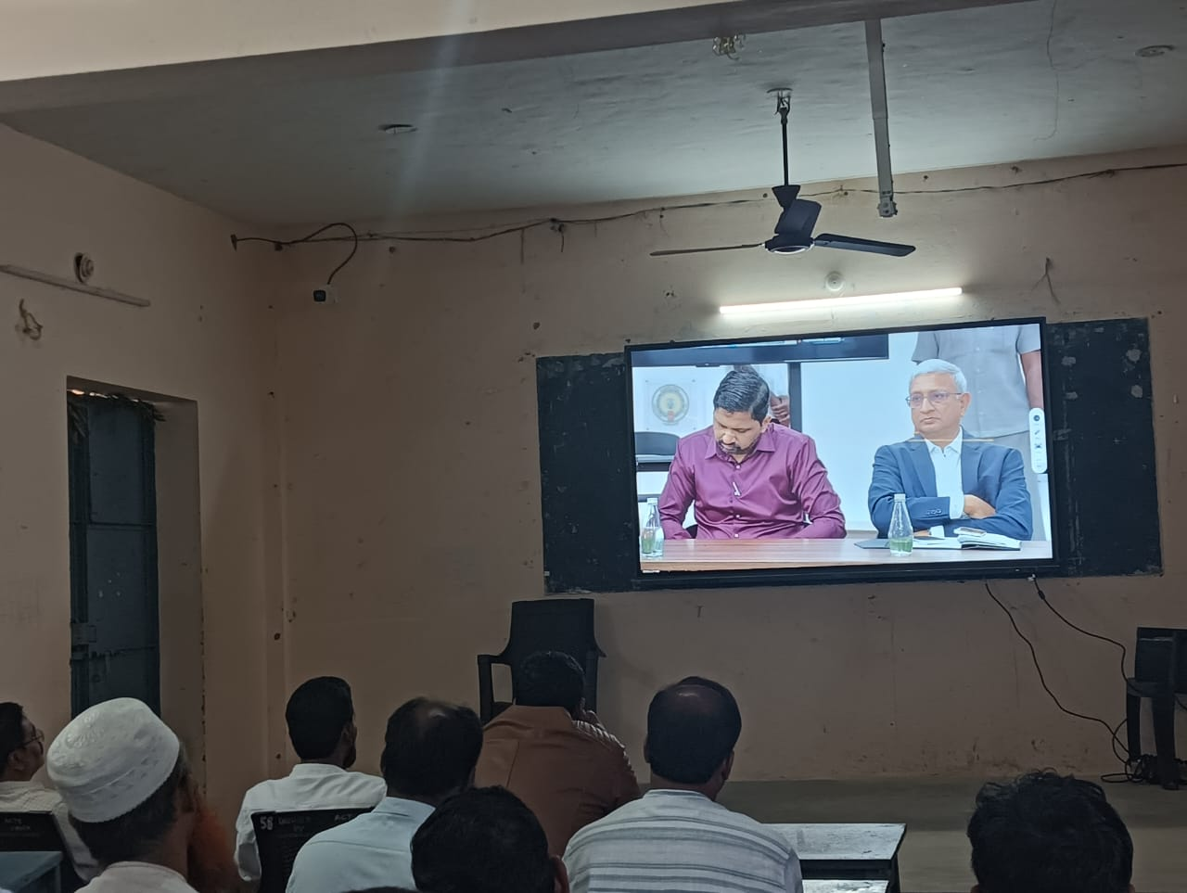
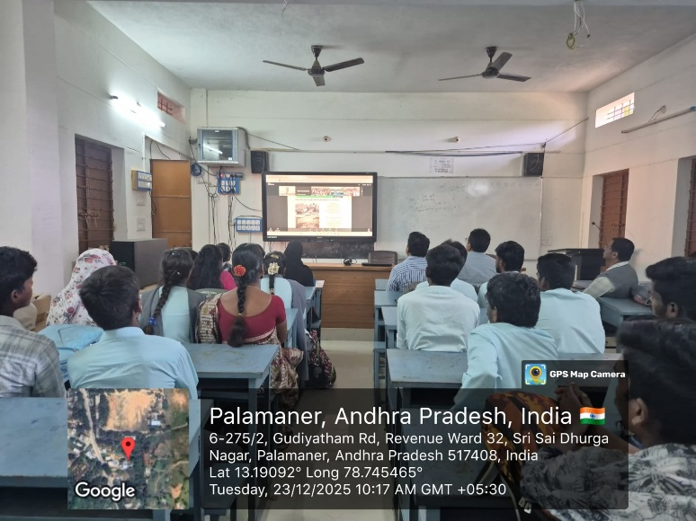
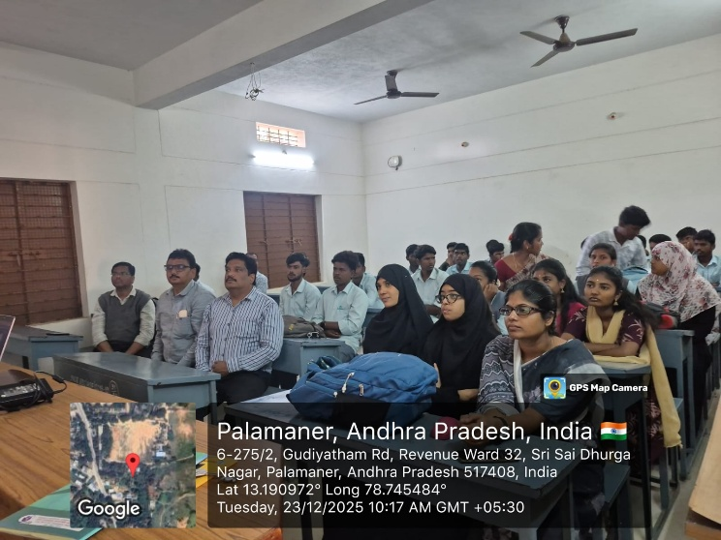
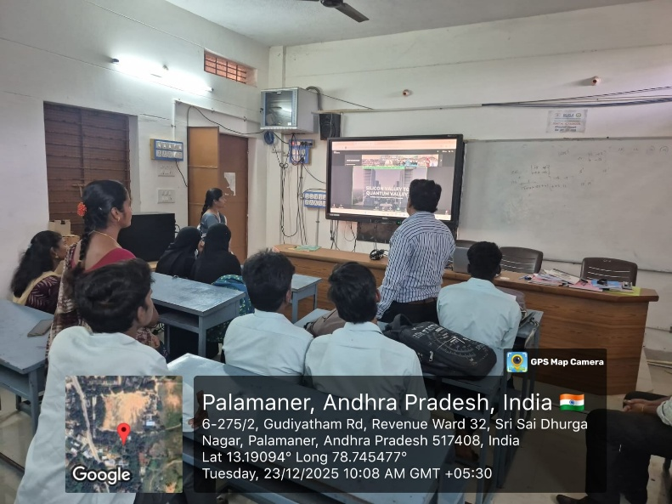
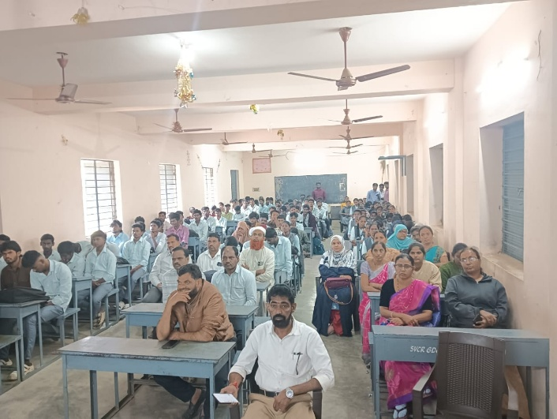
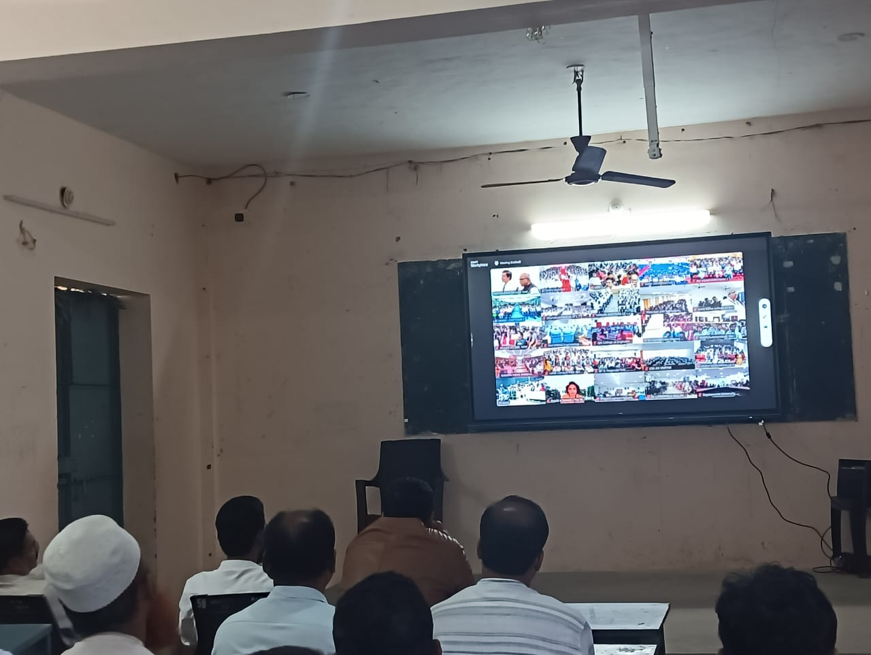

CAREER GUIDANCE PROGRAMME
24.12.2025
Report on Career Guidance Programme at SVCR Government Degree College, Palamaner
A Career Guidance Programme was conducted at SVCR Government Degree College, Palamaner, with the objective of guiding students towards better career planning and higher education opportunities.
The programme focused on creating awareness among students about various career options available after graduation, including higher studies, competitive examinations, and employment opportunities in both public and private sectors. Resource persons addressed the students and provided valuable insights on skill development, goal setting, and career planning.
Students were encouraged to identify their interests and strengths and were guided on how to prepare for future careers. The interactive session helped students clarify their doubts regarding career choices and motivated them to work towards achieving their goals.
The programme concluded successfully with active participation from students and faculty members, and it proved to be highly beneficial in shaping the career paths of the students.

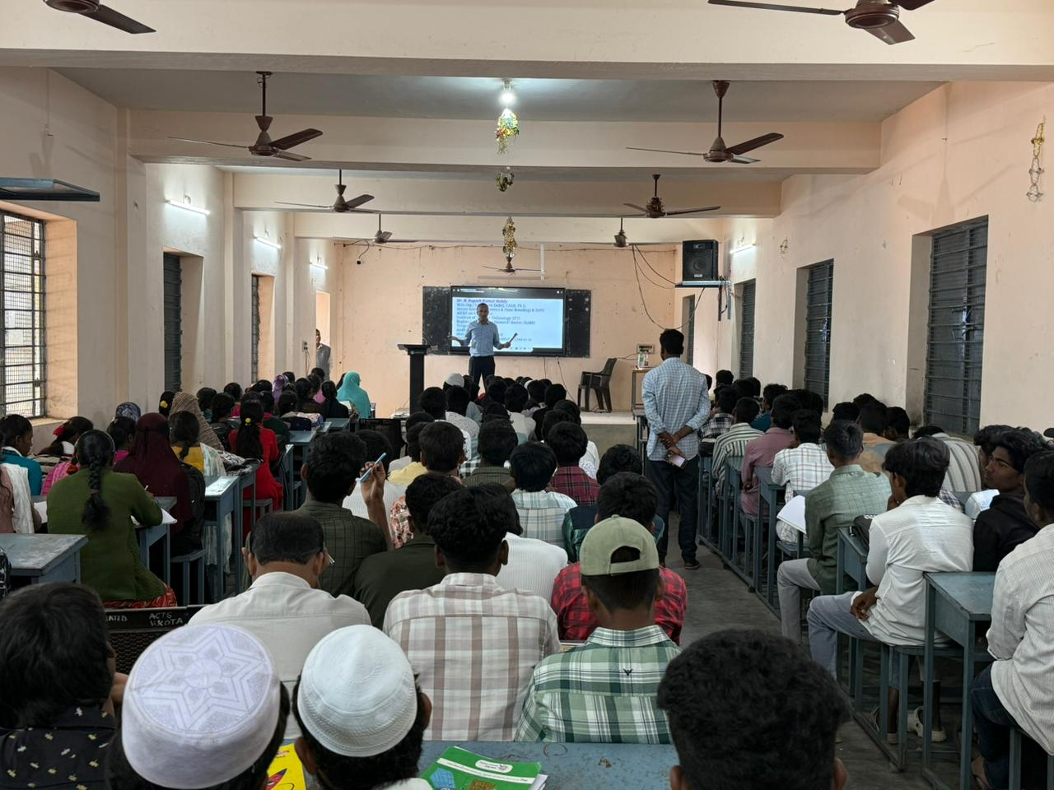
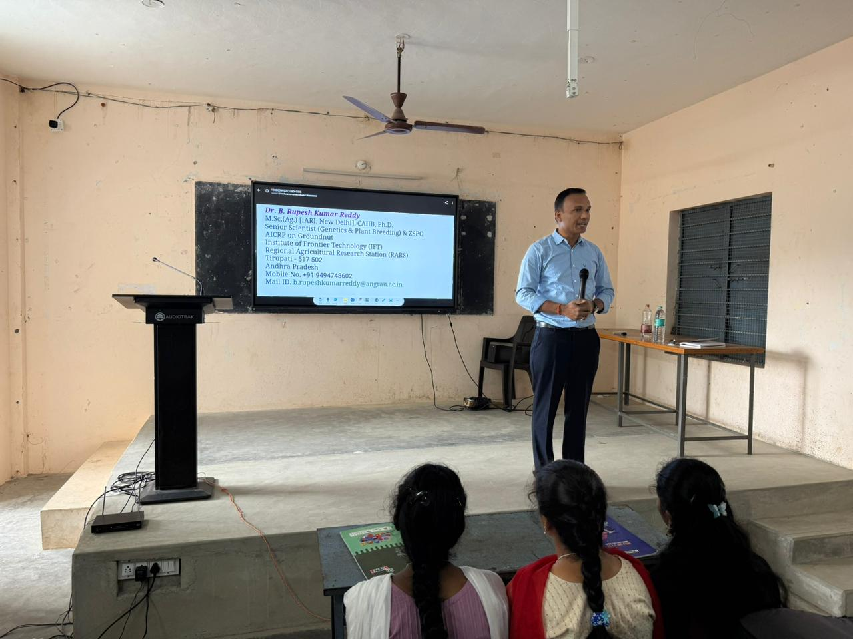

STUDENTS WIN CASH PRIZES AND CERTIFICATES AT NATIONAL CONSUMER DAY CELEBRATIONS, CHITTOOR
24.12.2025
On the eve of National Consumer Day Celebrations held at Chittoor, students of our college achieved remarkable success by winning cash prizes along with certificates in various competitions conducted on behalf of students.
Ms. O. Prasanna, a student of I B.Com CA, secured First Prize in Elocution and was awarded a cash prize of Rs. 5,000/- for her excellent performance.
Mr. M. Vinay Kumar, also from I B.Com CA, won First Prize in Essay Writing and received a cash prize of Rs. 5,000/-. He further showcased his talent by securing Second Prize in Elocution, for which he was awarded a cash prize of Rs. 3,000/-.
The students received their prizes and certificates during the celebrations. The college management and faculty members congratulated the prize winners for bringing laurels to the institution. Their achievement serves as an inspiration to other students to actively participate in academic and co-curricular activities.
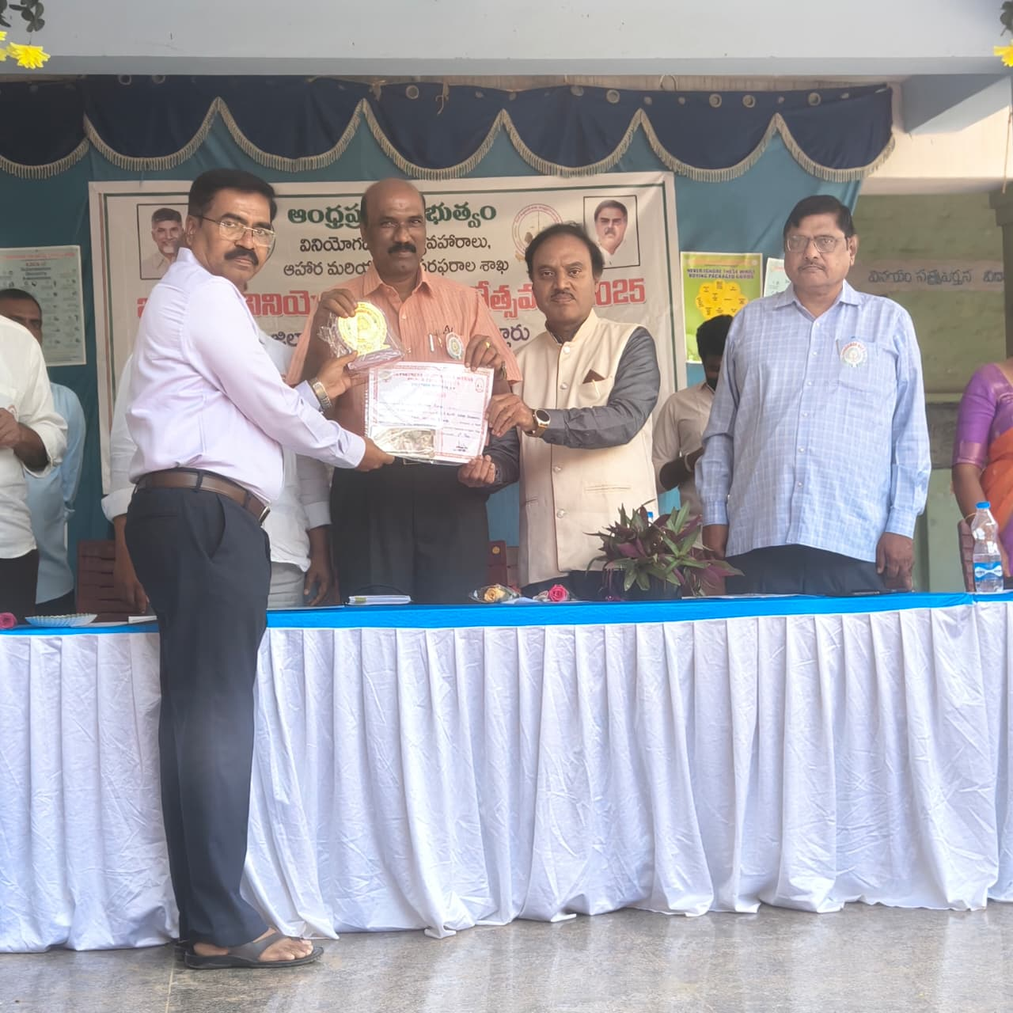

VEER BAL DIWAS: VOICES HONOURING THE SAHIBZADAS’ SACRIFICE
26.12.2025

Detailed Report
On the occasion of Veer Bal Diwas, SVCR Government Degree College organized a Debate and Elocution Programme to honour the extraordinary courage and sacrifice of the Sahibzadas. The programme was conducted to instill values of patriotism, bravery, and moral integrity among the students.
The event began with a brief introduction highlighting the historical significance of Veer Bal Diwas and the inspiring story of the Sahibzadas. Students from various departments actively participated in the debate and elocution competitions, expressing their thoughts on themes related to courage, sacrifice, national unity, and responsibility towards the nation. Their speeches reflected awareness, confidence, and respect for the nation’s heritage.
Faculty members served as judges and encouraged students to uphold ethical values and contribute positively to society. The programme provided a meaningful platform for students to enhance their communication skills while learning about the importance of courage and sacrifice. The event concluded with a vote of thanks, leaving a lasting impression of national pride and inspiration among the participants.
